Purchase your Northeast Hoodie today!
Support Athletics and Stay Warm This Winter
Great holiday, birthday or class year gift!
$25 each (cash, check or money order)
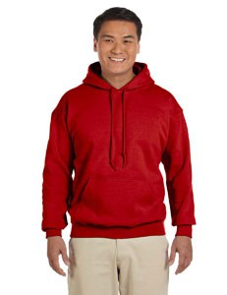

Preorder from Mrs. Randolph Room 17-23 by Friday Dec. 5
Checks payable to NEHI Athletic Boosters, Inc.

