Sunday, December
19th, 2021 10:00AM
Kick-Off at East Lake High School

Please come and support this
worthwhile cause
Featuring the Tony
Rosso XL vs. The Wanderers XL
With Tony’s former teammates,
collegiate alumni and
local soccer coaches
────
Admission to the match is free but a donation to the
Scholarship in Tony’s memory will be
gratefully accepted upon arrival
────
East Lake High School
1300 Silver Eagle Dr, Tarpon Springs, FL
34688
Please arrive by
9:30 AM
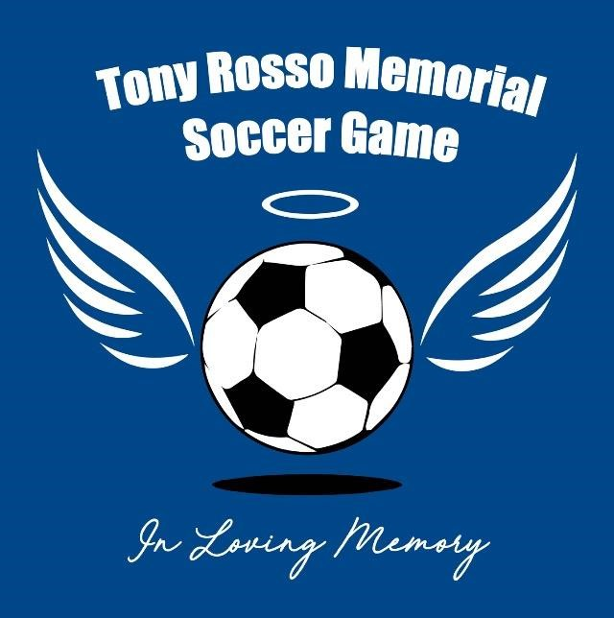
Tony Rosso Biography
Tony lost his life in a tragic and unreal circumstances on February 24th
2017, at age just 34 with his whole life ahead of him. Tony was an incurable soccer romantic; he dedicated his life to playing, dreaming of
being the best and helping others. Tony was the soccer captain at East
Lake High School. After that he received a scholarship and played collegiate Soccer for four years at St. Leo’s University. Additionally, he played professionally for the Florida Kickers in the Florida Suncoast Soccer League.
Tony was revered by teammates and opponents alike for his true sportsmanship. He was a truly competitive player but a gentleman on and off the pitch as well. His opponents greeted him with respect,
applause and a handshake after the game. Tony always put others before himself and was a true and loved leader.
Donations to: https://www.gofundme.com/f/the-tony-rosso-soccer-scholarship

