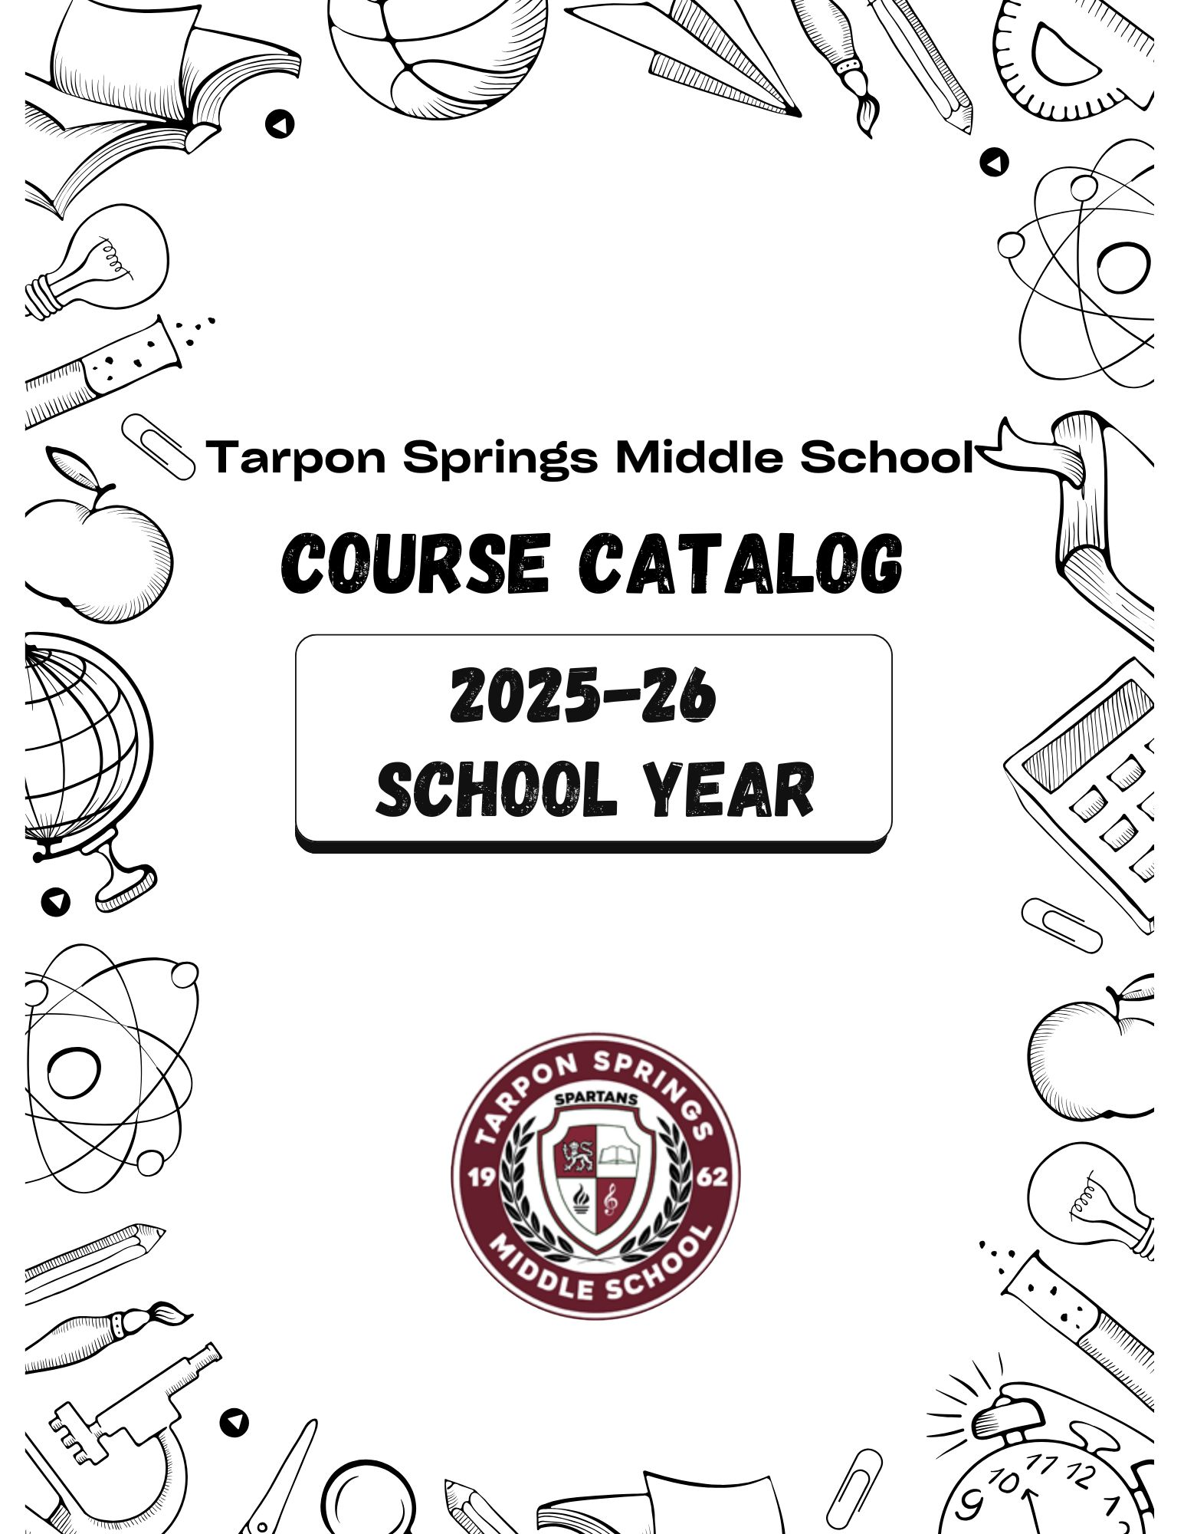

***College and Career Readiness Elective Options & Progression***

|  |  |  |  |
| --- | --- | --- | --- |
| Career Research & Decision Making (Wheel) | Grade 6  *Prerequisite: None* | | This introductory course provides students an opportunity to learn about the different elective choices offered at Tarpon Springs Middle School, with students attending each section of the wheel for about a 2-week period. Courses offered:   * Introduction to Spanish * Introduction to Band * Introduction to Orchestra * Introduction to Chorus * Technology/Engineering * Visual Art   Students will then choose ONE elective pathway for the second semester after exposure to all options available. |
| AVID 6th-8th *(Leadership Development Course)* | Grade 6-8  *Prerequisite: Enrollment in 1 or more advanced class* | | Each week, students receive instruction that utilizes a rigorous college-preparatory curriculum provided by AVID Center, tutor-facilitated study groups, motivational activities, and academic success skills. In AVID, students participate in activities that incorporate strategies focused on writing, inquiry, collaboration, organization, and reading to support their academic growth. Additionally, students engage in activities centered around exploring college and career opportunities and their own agency. |
| ICT 1 | Grade 6-8  *Prerequisite: None* | | The purpose of this course is to provide students with the computer, digital, and information technology skills necessary for success in their future academic and occupational goals. In addition to fundamental computer information, the content includes but is not limited to digital technologies associated with web development, multimedia, word processing, spreadsheet, database, Internet communications, cybersecurity, and computer programming. Instruction and learning activities are provided in a laboratory setting using hands-on experiences with the equipment, materials and technology appropriate to the course content and in accordance with current practices. |
| ICT 2 | Grades 7-8  *Prerequisite: None* | | This course builds on the previous course and provides greater depth and more complex concepts and the skills/knowledge to master these concepts. Students will be provided opportunities to extend their skills with various software applications by creating more complex documents and using more complex functions. |
| Marketing Essentials | Grade 8  *Prerequisite: Successful completion of ICT 1 and 2* | | This course blends theory and practice to facilitate immediate implementation and impact. Students will learn to develop strategic marketing with sales and customer plans. A review of the marketing environment is used to help develop the segmentation, targeting and market positioning strategy for implementation along with the marketing mix. The goal is the identification and delivery of organizational competitive advantage and customer satisfaction – key to long-term revenue growth, profitability and success. |
| Digital Information Technology  *High School Credit* | Grade 8  *Prerequisite: Successful completion of ICT 1 and 2* | | This core course is designed to provide a basic overview of current business and information systems and trends, and to introduce students to fundamental skills required for today's business and academic environments. Emphasis is placed on developing fundamental computer skills. The intention of this course is to prepare students to be successful both personally and professionally in an information-based society. Digital Information Technology includes the exploration and use of: databases, the internet, social media, spreadsheets, presentation applications, management of personal information and email, word processing and document manipulation, HTML, web page design, and the integration of these programs using software that meets industry standards. |
| Spanish 1  *High School Credit* | | Grade 7-8  *Prerequisite: None* | Spanish 1 introduces students to the target language and its culture. The student will develop communicative skills in all 3 modes of communication and cross-cultural understanding. Emphasis is placed on proficient communication in the language. An introduction to reading and writing is also included as well as culture, connections, comparisons, and communities. |
| Spanish 2  *High School Credit* | | Grade 8  *Prerequisite: Successful completion of Spanish 1* | Spanish 2 reinforces the fundamental skills acquired by the students in Spanish 1. The course develops increased listening, speaking, reading, and writing skills as well as cultural awareness. Specific content to be covered is a continuation of listening and oral skills acquired in Spanish 1. Reading and writing receive more emphasis, while oral communication remains the primary objective. The cultural survey of the target language-speaking people is continued. |

***Fine Arts Elective Options & Progression***

*Note: Public performances may serve as a culmination of specific instructional goals. Students may be required to attend and/or participate in rehearsals and performances outside the school day to support, extend, and assess learning in the classroom. This course may also require students to obtain a musical instrument (e.g., borrow, rent, purchase) from an outside source.*

|  |  |  |
| --- | --- | --- |
| Band 1 | Grades 6-8  *Prerequisite: None* | No experience required. Students with little or no instrumental experience develop foundational instrumental technique, foundational music literacy, and aesthetic musical awareness through rehearsal, performance, and study of high-quality band literature. |
| Orchestra 1 | Grades 6-8  *Prerequisite: None* | Students will develop performance techniques, ear training, music fundamentals, bowing, and posture while performing a wide variety of string music. |
| Chorus 1 | Grades 6-8  *Prerequisite: None* | Students will develop healthy vocal technique, critical thinking, teamwork, and music literacy through a variety of music literature and performances. |
| Dance 1 | Grades 6-8  *Prerequisite: None* | Students develop dance technique and movement vocabulary in two or more dance forms. In the process, dancers demonstrate use of class and performance etiquette, analytical and problem-solving skills, and studio practices in a safe dance environment. |
| Keyboarding 1 | Grades 6-8  *Prerequisite: Enrollment in a fine arts elective* | Students with little or no prior experience develop fundamental piano techniques, learn to read music, apply basic music theory, and explore the role of keyboard music in history and culture. |
| Visual Art 1/2D Studio Art | Grades 6-8  *Prerequisite: None* | Students are introduced to the rigor and routine of the art production process including: planning, producing, and reflecting on art. With an emphasis on studio arts, students explore a wide range of 2D and 3D media, skills and techniques, as related to contemporary and historical art perspectives. Projects may include but not be limited to: drawing, painting, printmaking, collage, mixed media, pottery, and sculpture. |
| Band 2 | Grades 7-8  *Prerequisite: Completion of Band 1; documented previous training will be considered* | Students with previous band experience build on instrumental technique, music literacy, and aesthetic response through rehearsal, performance, and study of a variety of high-quality band literature. Instrumentalists expand their knowledge of music notation, music theory, sound production, and personal and group rehearsal  strategies. |
| Orchestra 2 | Grades 7-8  *Prerequisite: Completion of Orchestra 1; documented previous training will be considered* | Students who have some previous orchestral experience focus on the development of instrumental technique, musical literacy, performance skills, and increasing aesthetic awareness through study, rehearsal, and performance of a variety of high-quality orchestra literature. |
| Chorus 2 | Grades 6-8  *Prerequisite: None* | All levels are accepted. Students will develop and expand vocal, technical, musical and ensemble skills through rehearsal, performance, and the study of high-quality choral literature. |
|  |  |  |

|  |  |  |
| --- | --- | --- |
| Musical Theater 1 | Grades 7-8  *Prerequisite: Chorus 1* | Student’s coursework focuses on, but is not limited to, basic acting, basic vocal performance, basic dance/movement, non-dance movement, and staging, which transfer readily to musical theater. Students will survey the current trends in  musical theater by studying representative literature. |
| Dance 2 | Grades 7-8  *Prerequisite: Completion of Dance 1* | Students attend to alignment, acquisition of complex technical skills, collaborative problem solving, dance conditioning, and safe studio practices. They learn about dance in its cultural and historical contexts through research and physical experiences, explore exemplary modern works, employ dance as a healthy life skill, and use dance terminology appropriately. |
| Visual Art 2/2D Art 2 | Grades 7-8  *Prerequisite: Completion of Visual Art 1/2D Art 1* | In Visual Art 2, students explore contemporary and historical art themes using 2D and 3D media, skills and techniques. Projects may include but are not limited to: drawing, painting, printmaking, collage, mixed media, ceramics, and sculpture. In 2D Art 2, students will continue to develop their technical artistic skills through an intensive study of 2D art mediums, including: drawing, painting, printmaking, collage, and digital art. |
| Digital Art and Design | Grades 7-8  *Prerequisite: Completion of Visual Art 1/2D Art 1* | Students explore the fundamental concepts, terminology, techniques, and applications of digital imaging to create original work. Students produce digital still and/or animated images through use of computers, digital cameras, digital video cameras, photo editing software, and drawing and painting software. Through the critique process, students evaluate and respond to their own work and that of their peers to measure artistic growth. This course incorporates hands-on activities, the  use of technology, and consumption of art materials. |
| Band 3 | Grade 8  *Prerequisite: Teacher recommendation* | One or more years of Band experience. Students with previous band experience expand on their instrumental technique, music literacy, and aesthetic response through rehearsal, performance, and study of a variety of intermediate-level, high-quality band literature. Instrumentalists extend their knowledge of music notation and theory, sound production, and personal and group rehearsal strategies. |
| Orchestra 3 | Grade 8  *Prerequisite: Teacher recommendation* | One or more years of Orchestra experience. Students with previous orchestra experience expand on their instrumental technique, music literacy, and aesthetic response through rehearsal, performance, and study of a variety of intermediate-level, high-quality band literature. Instrumentalists extend their knowledge of music notation and theory, sound production, and personal and group rehearsal strategies. |
| Chorus 3 | Grade 8  *Prerequisite: Teacher recommendation* | This year-long, formative class, designed for students with previous participation in a school chorus who have basic knowledge of note-reading and vocal technique, concentrates on providing students opportunities to strengthen existing skills in critical listening, vocal techniques, and ensemble performance using high-quality three- and four-part choral literature. Rehearsals focus on gaining independence in music literacy and aesthetic engagement through critical listening and thinking skills. |
| Dance 3 | Grade 8  *Prerequisite: Teacher recommendation* | Students attend to alignment, acquisition of complex technical skills, collaborative problem solving, dance conditioning, and safe studio practices. They learn about dance in its cultural and historical contexts through research and physical experiences, explore exemplary modern works, employ dance as a healthy life skill, and use dance terminology appropriately. |
|  |  |  |

|  |  |  |
| --- | --- | --- |
| Pre-AP Music  *High School Credit* | Grade 8  *Prerequisite: Teacher recommendation* | One or more years of band/orchestra/chorus experience. Students with previous band experience expand on their instrumental technique, music literacy, and aesthetic response through rehearsal, performance, and study of a variety of intermediate-level, high-quality band literature. Instrumentalists extend their knowledge of music notation and theory, sound production, and personal and group rehearsal strategies. |
| Instrumental Ensemble (Jazz Band) | Grade 8  *Prerequisite: Teacher recommendation* | Students with previous band experience expand on their instrumental technique, music literacy, and aesthetic response through rehearsal, performance, and study in the jazz idiom. Instrumentalists extend their knowledge of music notation and theory, sound production, and personal and group rehearsal strategies. |
| Pre-AP Visual Art & Design  *High School Credit* | Grade 8  *Prerequisite: Teacher recommendation* | The Pre-AP Arts areas of focus are vertically aligned to the practices embedded in high school and college arts courses, including AP. This gives students multiple opportunities to prioritize and strengthen these disciplinary skills throughout their course of study. |