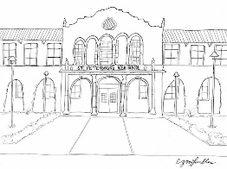

**SPHS Title 1 Compact Shared Responsibilities for Highest Student Academic Achievement**

*Parent/Guardian Agreement*:

I want my child to reach their full academic potential; therefore, I will do the following to support my child’s learning. Have on-going communications with my student’s school, including parent-teacher conferences. Support the school staff and respect cultural differences of others. Participate in school events. See that my student attends school daily, is punctual and has all needed supplies. Talk to my student weekly about homework and academic progress.

Parent/Guardian Signature _____________________________ Date __________________

Print Parent/Guardian Name _________________________________

*Student Agreement:*

It is important that I do the best that I can; therefore, I will do the following: Come to school each day on time with my homework completed and with supplies that I need. Show respect for my school, myself, peers, and have consideration for cultural differences. Believe that I can learn, and I will learn. Work to the best of my ability. Follow the rules of student conduct at my school.

Student Signature _________________________________ Grade ___ Date _____________

Print Scholar Name _________________________________

*School Agreement:*

The entire school staff will share the responsibility for improved scholar achievement; therefore, we will do the following: Hold parent/teacher conferences. Send reports to parents on their child’s progress. Provide opportunities for parents to volunteer and participate in their child’s school activities. Provide an environment conducive to learning. Respect the scholar, their parents and the diverse culture of the school.

Staff Signature_____________________________ Date ____________________

*Note: This compact (pledge) is a voluntary agreement designed to promote a partnership between the parent/guardian, scholar and school. It meets the requirement of the Title 1 Federal Guidelines*