**2023-2024**

**East Lake High School**

**Engineering Academy Course Descriptions**

**Engineering Courses**

**Engineering, Robotics, and Gaming Courses are Restricted to Engineering Academy Students**

**Applied Engineering Technology I**

Grade 9

Credit 1

This course helps students understand the field of engineering/engineering technology and prepares them for postsecondary engineering programs by developing a more in-depth mastery of the associated mathematics, science, and technology knowledge and skills. The course also includes essential concepts of technology and design, as well as concerns about the social and political implications of technological change.

Students will have the opportunity, pending grades, to certify in REC Foundations as well as Autodesk Fusion 360

**Applied Engineering Technology II**

Grade 10

Credit 1

This is the second course in the Eagle Works Academy Engineering Pathway. Extending on knowledge from the previous year, the focus of the class is on the implementation and documentation of the engineering design process. This class uses a learn-by-doing methodology where students must work collaboratively to complete engineering design challenges that utilize concepts from mechanical engineering and computer programming. The second focus is on acquiring an industry certification provided by the REC Foundation.

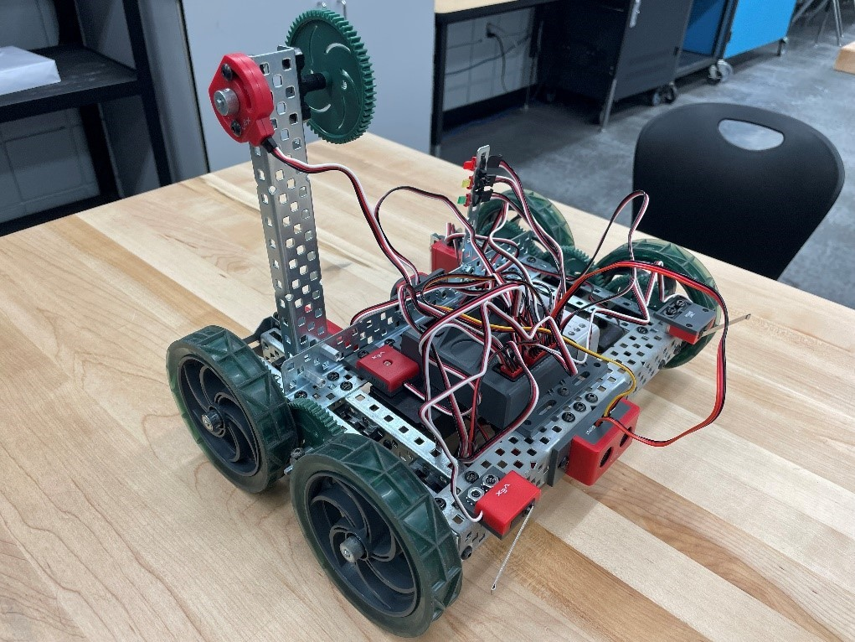

Figure A robot that students learn to program in AETII in order to learn fundamentals of programming and automation.

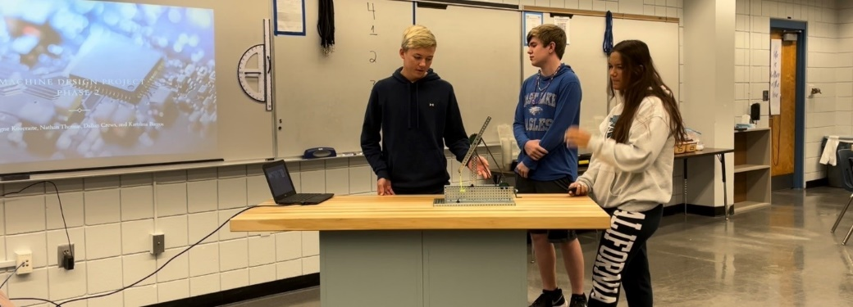

Figure Students giving a presentation of a project they designed for AETII

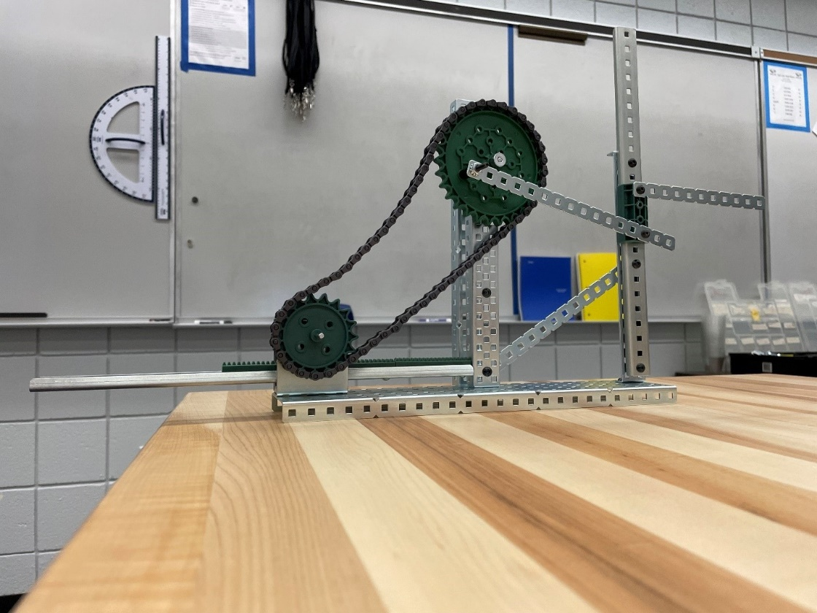

Figure An example of a device that students designed and built for AETII

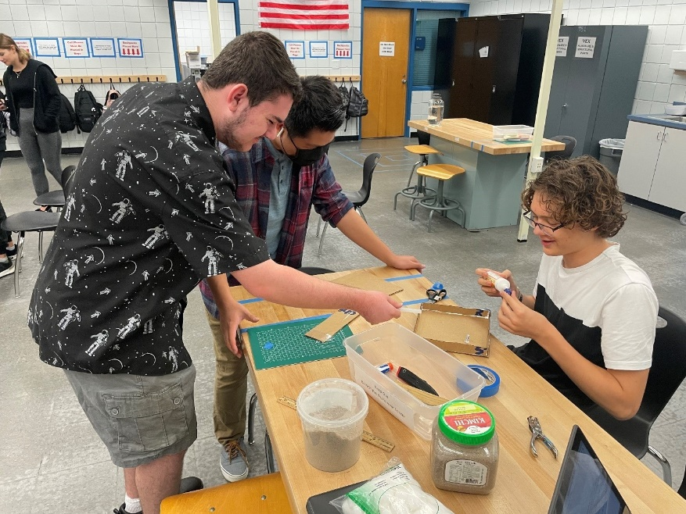

Figure Students working on building their design for a Renewable Insulation.

**Applied Engineering Technology III**

Grade 11

Credit 1

This course provides opportunities for students to apply their acquired knowledge and skills in engineering scenarios. The course features multiple options for providing context-based projects oriented to specific fields of engineering. This feature enables instruction in complex projects involving multi-faceted project teams by providing instruction oriented to four key engineering disciplines: mechanical, electrical, civil, and environmental.

**Advanced Technology Applications**

Grade 12

Credit 1

The purpose of this course is to serve as a capstone course to provide Engineering and Technology Education students with the opportunity, to develop a project from "vision" to "reality". Working in teams to design, engineer, manufacture, construct, test, redesign, test again, and then produce a finished "project". This would involve using ALL the knowledge previously learned, not only in technology education, but across the curriculum.

**Robotics Courses**

**Foundations of Robotics**

**Grade 9**

**Credits 1**

This course provides students with a foundation in content and skills associated with robotics and automation, including artificial intelligence, electronics, physics, and principles of engineering. Students will use virtual and physical robots to engage in programming projects related to Robotics utilizing block and Python coding

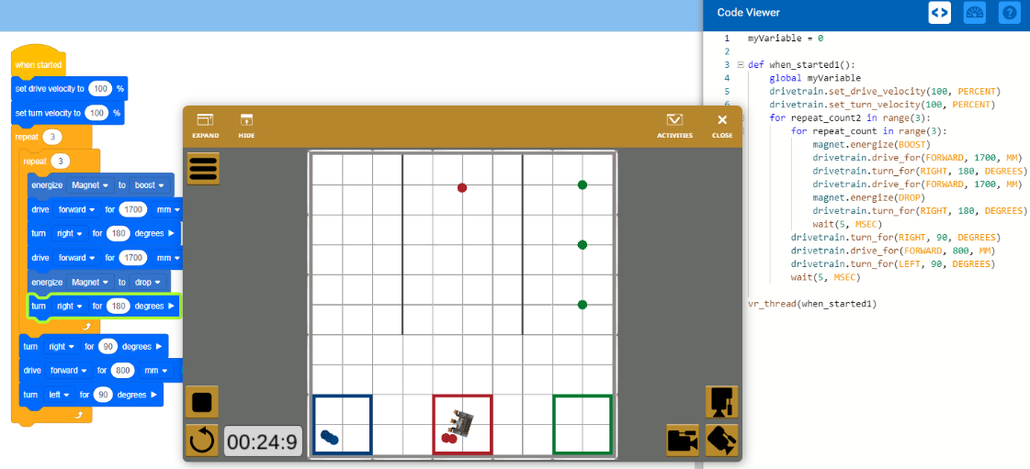

Figure A Screenshot of Vex VR running through a program

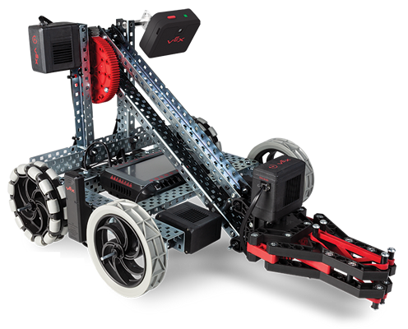

Figure A close-up of a Vex Clawbot

**Robotics Design Essentials**

**Grade 10**

**Credits 1**

This course provides students with content and skills essential to the design and operation of robotics, including artificial intelligence, sensors, electronic devices, engineering technologies, motion physics, electrical motors, programming, simulation and modeling, and critical thinking skills.

Following are some of the main modules we cover:

**Linux for Robotics**

Robot Operating System (ROS) is a set of software frameworks for robot software development. It is a preferred open-source framework to program virtual robots that is fully supported only by Linux systems. In this module, we master essential Linux knowledge in order to utilize ROS.

**Python for Robotics**

Python is the most popular programming language for robots, and it is also the faster and easier way to learn ROS. In this module, we master basic Python knowledge in order to program robots.

**Computer Vision with OpenCV and Deep Learning**

This course is an introduction to applying computer vision techniques to real-world problems. We start off by learning how to use OpenCV and Python to work with images and videos. After learning the basic building blocks of computer vision, we tackle real-world problems such as detecting human-faces or reading license plates. Finally, we learn how to use state-of-the-art tools such as Tensorflow to perform image classification with deep learning.

**Robotics Systems**

**Grade 11**

**Credits 1**

This course provides students with extended content and skills essential to the design and operation of robotic systems, including artificial intelligence, specialized sensors, electronic applications, engineering technologies, environmental physics, manufacturing, topographical considerations, programming, communications, simulation and modeling, and critical thinking skills.

**Robotics Application Capstone**

**Grade 12**

**Credits 1**

This course provides students with extended content and skills essential to the design and operation of autonomous robotic systems in the context of a capstone project.

**Game and Simulation Courses**

The culmination of the Game and Simulation course progression will result in the students having at least 3 opportunities to certify using the Unity Game engine and other industry standard software.

**Game and Simulation Foundations**

Grade 9

Credit 1

This course is designed to provides an introduction to game and simulation concepts and careers, the impact game and simulation has on society and industry, and basic game/simulation design concepts such as rule design, play mechanics, and media integration. This course compares and contrasts games and simulations, key development methodologies and tools, careers, and industry-related information. This course also covers strategies, processes, and methods for conceptualizing a game or simulation application; storyboarding techniques; and development tools.

Hands-on activities using an entry-level game development tool should be integrated into the curriculum. **Regardless of topic sequencing, the culminating activity is the creation of a playable game.**

**Game and Simulation Design**

Grade 10

Credit 1

This course covers fundamental principles of designing a game or a simulation application, rules and strategies of play, conditional branching, design and development constraints, use of sound and animation, design tools, and implementation issues. The content includes market research, product design documentation, storyboarding, proposal development, and presentation of a project report. Emphasis is placed on the techniques needed to develop well-documented, structured game or simulation programs. Extensive use is made of evaluating and analyzing existing games or simulations.

**Game and Simulation Programming**

Grade 11

Credit 1

This course is focused on students acquiring the appropriate programming skills for rendering a game or simulation product, including program control, conditional branching, memory management, score-keeping, timed event strategies and methodologies, and implementation issues.

Standards included in this course of instruction have aligned to the academic courses shown below. This table shows the number of aligned benchmarks, the total number of academic benchmarks, and the percentage of alignment been.

**Multi-User Game and Simulation Programming**

Grade 12

Credit 1

This course is focused on students acquiring the appropriate programming skills for rendering a game or simulation product, including program control, conditional branching, score-keeping, timed event strategies and methodologies, and implementation issues specific to multi-user game/simulation products.