**Step-by-step directions for finding & requesting a library book**

“Follow the directions **below** to find a book in Destiny and then email me back the **title** so I can check it out to you and put it in the front office for you to pick up 😊”

----------------------------------------------------------------------------------------------------------------------------------------

1) Think of a **subject** that you are interested in (soccer, dance, dogs, gardening, sci fi, dystopia, mystery etc...)

2) Go to **Clever** & find **Destiny**

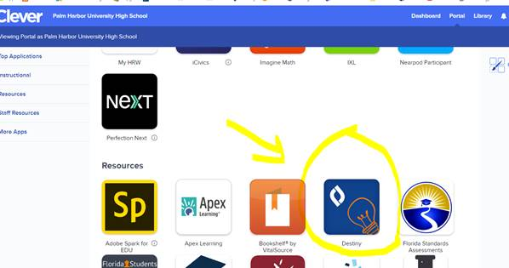

3) You may have to **fill in this page** if you haven’t used Destiny before

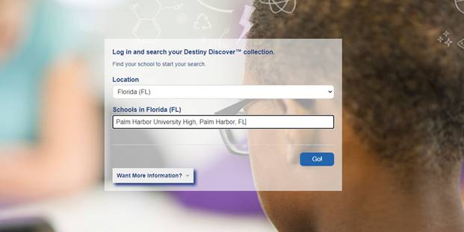

4) (optional) **Set your parameters** so that you are searching for Reading Counts books

                1 -  click “Search Options”

                2 – Make you **options** **MATCH** mine in the pic (if your teacher specified a minimum number of

                      points)

                3 – Click “Set Options”

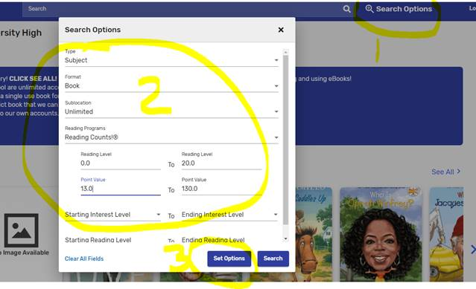

5) Now Search 😊

                1 – pick a **subject** (I chose “DOGS”)

                2 – Make sure you pick a book with a **GREEN** “**IN**” flag

                3 – You can see the **Reading counts points** on the RIGHT

                4- Click on the **TITLE** to read a synopsis of the book

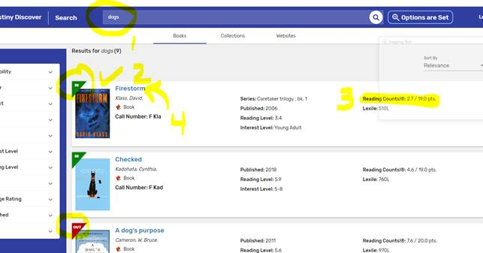

**6) FINALLY, email me the title of the book that you want and I will check it out in your name and place it in the FRONT OFFICE for you or a parent/guardian to pick up😊**

[**Crosleyj@pcsb.org**](mailto:Crosleyj@pcsb.org)