Largo High School

Memorable Bricks

Name: ______________________________________________________________

Address: ____________________________________________________________

Phone Number: _______________________

4 X 8 Personal Bricks $50.00

___ 3 Lines 20 Characters with no Clipart

___ 3 Lines 20 Characters with Clipart Number _______

______________________________________

______________________________________

______________________________________

8 X 8 Family Bricks $100.00

___ 6 Lines 20 Characters with no Clipart

___ 5 Lines 20 Characters with Clipart Number ________

______________________________________

______________________________________

______________________________________

______________________________________

______________________________________

______________________________________

Mail form and check to**: Largo High School (Attn. Athletic Boosters)**

**410 N Missouri Ave.**

**Largo, Fl 33770**

Or go to: **Largohsathleticboosters.com**

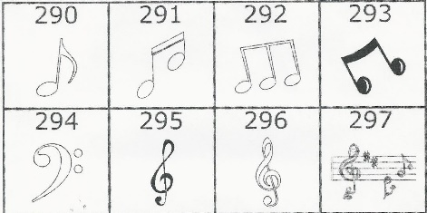 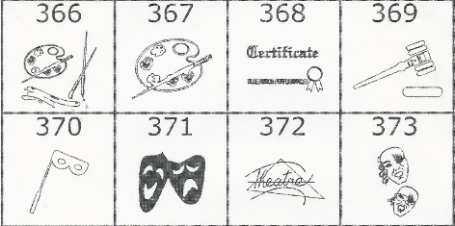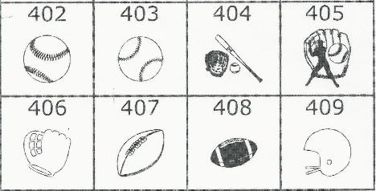 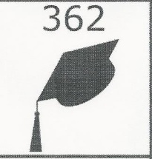 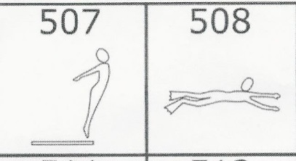

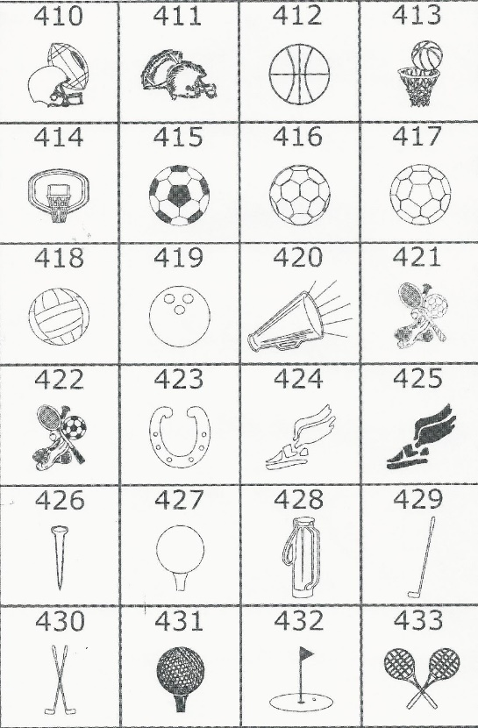 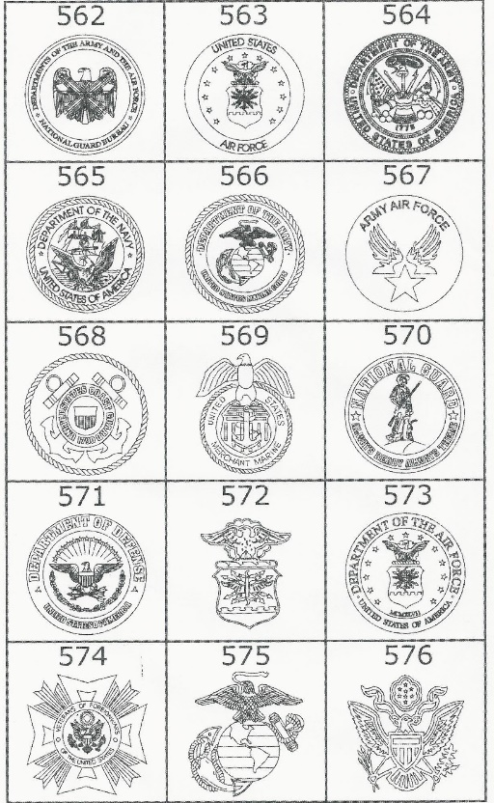

Or IB or Excel