**New Federal Standards: SMART SNACKS IN SCHOOL, July 1, 2014**

Provided USDA authority to establish nutrition standards for all foods and beverages sold outside of the Federal child nutrition programs in schools. The law specifies that the nutrition standards shall apply to **ALL FOODS SOLD**:

* Outside the school meal programs
* On the school campus
* At any time during the school day
* Including:
  + a la carte in the cafeteria
  + in school stores
  + snack bars
  + vending machines
  + other venues

**What are competitive foods?**

Competitive food: all food and beverages sold to students on the School campus during the School day, other than those meals reimbursable under programs authorized by the NSLA and the CNA.

**Where do the standards apply?**

School campus: all areas of the property under the jurisdiction of the school that are accessible to students during the school day.

**When do the standards apply?**

School day is the period from the midnight before, to 30 minutes after the end of the official school day.

**How will the new standards affect fundraising by school groups?**

• All foods that meet the standards could be sold during fundraisers during school hours.

• The standards do not apply to items sold during non-school hours, weekends or off-campus fundraising events, such as concessions during sporting events and school plays.

**Beverage Issues**

**Beverages for All**

* Water
* 100% Juice
* [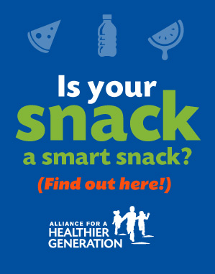](http://r20.rs6.net/tn.jsp?e=001BhcTso-jrnnrDogWhsuuW9jxcJYYARga6MzuTzDRjXEtto6Haq_w7TVMCNV1M6mc_3K8DqL303RtreJ_69EX6kg6gF8doxC6TOafpGfhFSzAGHRMgQGuUJ_JHQ0laP8EjYw_-R3U8yvjkrJIx-Us8jKmkBK9ymZGhNCr2NfSC_RRdYfIqR2OVWCL7_Ea9dyvbaFK_xILXYPRLgbLX0QdiCxE3xG6GNsBBdGFIUEWn8HwG0JKrtnFlrvn4kpceXJk1caCzvRhi1dqGm9rBBznDNUy5EWnM_szsB9rQNzToOg=)Milk
  + Unflavored nonfat and lowfat milk
  + Flavored nonfat milk
  + Maximum serving sizes:
    - 8 fluid ounces in elementary school
    - 12 fluid ounces in middle and high schools

**Other Beverages in High School**

* Lower-Calorie Beverages - Maximum Serving Size 12 fluid ounces
* Up to 60 calories per 12 fluid ounces; or
* Up to 40 calories per 8 fluid ounces

**Resource**

* **Smart Snacks Calculator from the Alliance for a Healthier Generation**

<https://schools.healthiergeneration.org/focus_areas/snacks_and_beverages/smart_snacks/>