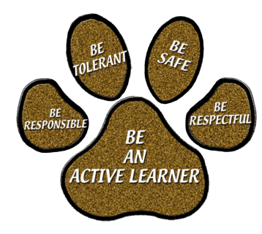
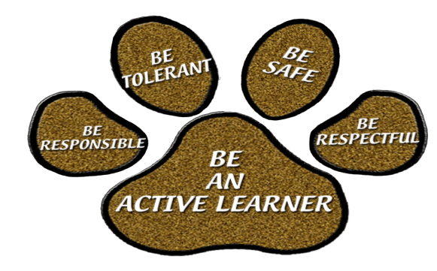

Frontier Elementary School
Home of the Frontier Panthers
Gina Owens, Principal Stephanie Stevens, Assistant Principal

Title I Annual Missed Meeting Notification

September 20, 2024

Dear Families,

Did you miss our Title I Annual Meeting? During our Title I Annual Meeting we discussed the following: Parent-School-Student Compact, our school and Pinellas County Schools Parent and Family Engagement Plan (PEEP), Title I budget, academic expectations, assessments, Title I Parent s Right to Know, and the Title I Program.

Please view the recording of our Annual Meeting on our school’s website https://www.pcsb.org/Frontier-es

We look forward to meeting you at future school events. Please call (727) 548-7335, if you have any questions or concerns regarding our school or our Title I Program.

Sincerely,

Gina Owens
Principal

