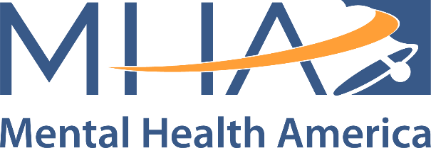

Spanish Toolkit

<https://mhanational.org/young-minds/spanish>