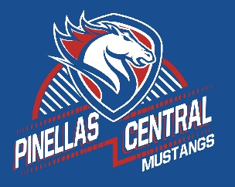

**Pinellas Central Elementary School**

**Kindergarten School Supply List 2022-2023**

**Student Items (for individual students use)**

* headphones or earbuds
* 3 plastic folders with pockets (red, yellow, green)
* 1 plastic folder with pockets for homework and parent information.
* crayons, glue sticks, full size backpack (no wheels),
* no binders, and no tab dividers.
* pencils
* erasers
* one pencil box for each child.