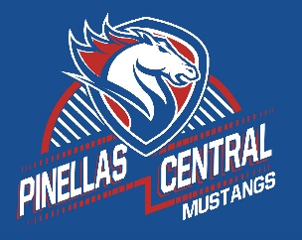

**Pinellas Central Elementary School**

**PreK School Supply List 2022-2023**

**Student Items (for individual students use)**

* full sized backpack-no rolling backpacks or mini backpacks
* extra change of clothes including underwear and socks in a large plastic zipper bag labeled your child’s name
* small blanket and a standard crib size sheet for the cot for rest time.
* refillable sports bottle with your child’s name on it.
* clearview 1 inch 3 ring binder. (clear pocket on front of binder)

**Supplemental Classroom Items-Donations Welcome**

* 3 ounce paper cups
* paper towels
* facial tissues
* baby wipes
* hand sanitizer
* disinfecting wipes
* liquid glue
* glue sticks
* play dough
* markers
* dry erase markers
* **healthy items** for snack time: pretzels, goldfish crackers, raisins, graham crackers, cereal, fruit snacks, and animal crackers.