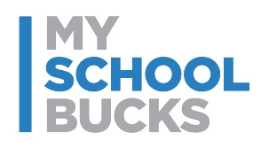
NEW! Pay for Student Meals Online


Dear Parents:
Pinellas County Schools Food Service is excited to offer MySchoolBucks®! This online payment service provides a quick and easy way to add money to your student’s meal account using a credit/debit card or electronic check.
You can also view recent purchases, check balances, and set-up low balance alerts for FREE!
MySchoolBucks provides:
- Convenience - Available 24/7 on the web or with the Mobile App for your iPhone, Android or Windows phone!
- Efficiency - Make payments for all your students, even if they attend different schools within the district. Eliminate the need for your students to take money to school.
- Control - Set low balance alerts, view account activity, recurring/automatic payments & more!
- Flexibility - Make payments using credit/debit cards and electronic checks.
- Security – MySchoolBucks adheres to the highest security standards, including PCI and CISP.
Enrollment is easy!
- Go to www.MySchoolBucks.com and register for a free account.
- You will receive a confirmation email with a link to activate your account.
- Add your students using their school name and your child’s 10 digit local student ID number.
- Make a payment to your students’ accounts with your credit/debit card or electronic check.
There will be a $2.50 fee per transaction. You will have the opportunity to review any fees and cancel if you choose, before you are charged.

If you have any questions, contact MySchoolBucks directly:
- parentsupport@myschoolbucks.com
- 1-855-832-5226
- Visit myschoolbucks.com and click on Help/FAQ’s
Thank you,
Pinellas County Schools Food Service

