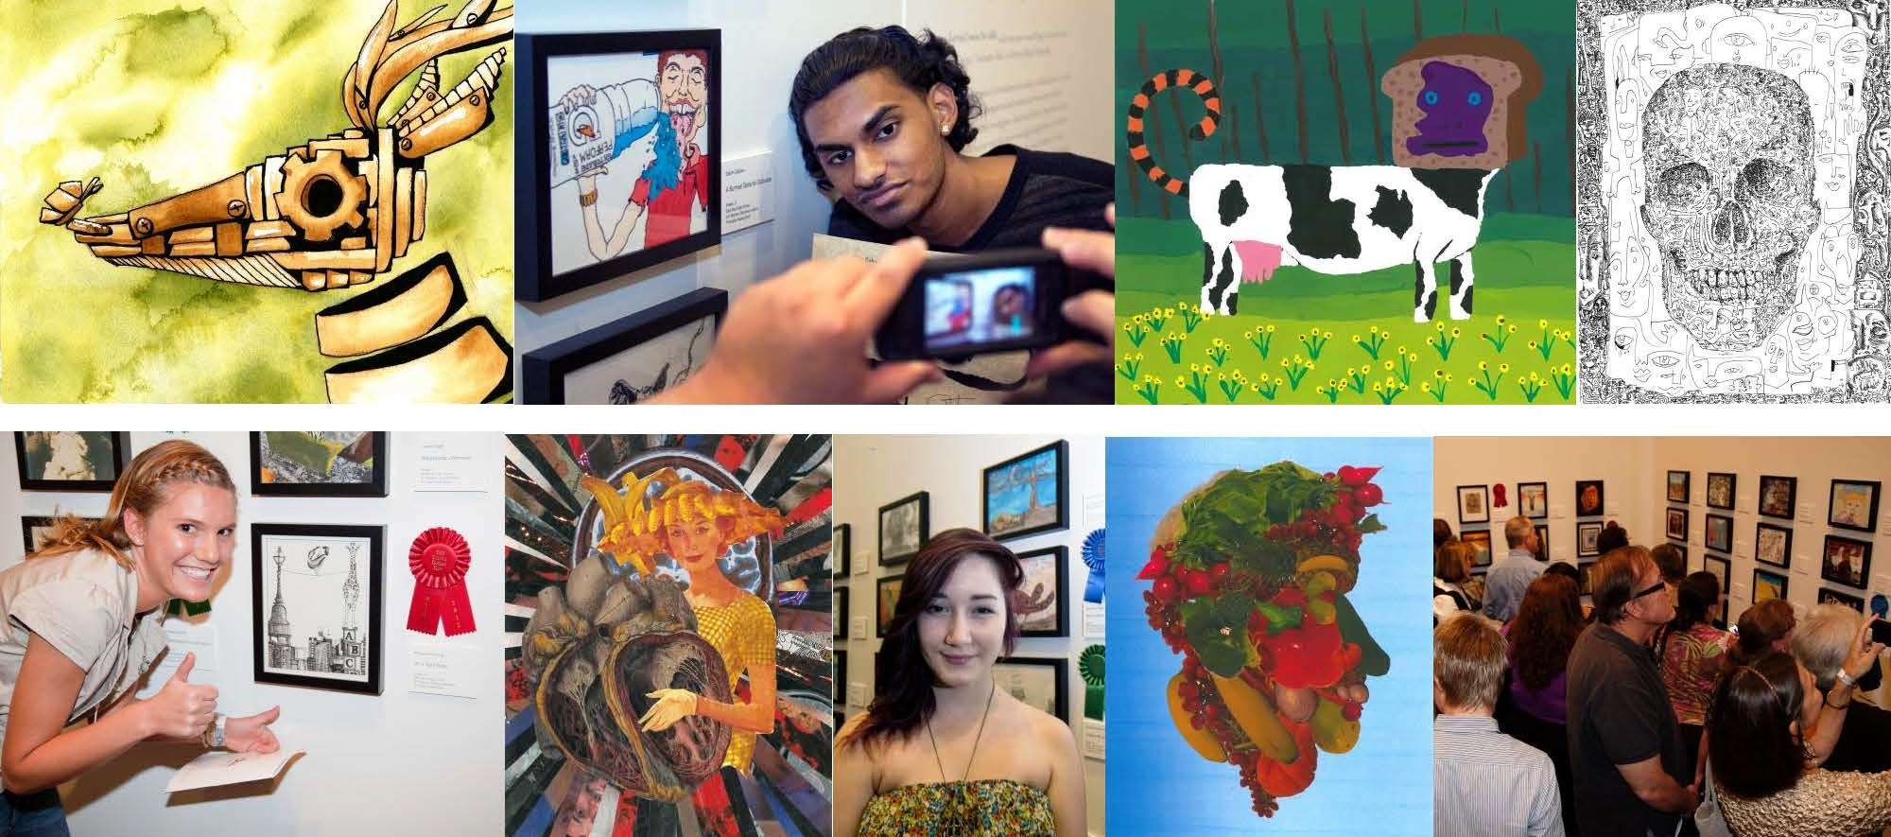

**The Dali Museum Student Surrealist Art Exhibition, 2014**

**Change is Strange**

<http://www.thedali.org/education/exhibits.php>

"I see the human form in trees, animals: the animal and vegetable in the human. My art shows the metamorphosis that takes place." Salvador Dalí

**met•a•mor•pho•sis /ˌmetəˈmôrfəsəs/**

Noun

1. Familiar images are changed in form, appearance, nature, condition, character or function to become unusual or strange.

2. A change of the form or nature of a thing or person into a completely different one, by natural or supernatural means.

Synonyms

transformation - transfiguration – shape-shifting– illusion

Surrealism invites us into a world where even the most seemingly insignificant occurrences of everyday life can be transformed in order to surprise, to be made strange, shocking or even disturbing. With this year’s exhibit, we invite the students to explore metamorphosis in a variety of media such as drawing, collage, watercolor, acrylic, digital photography, and mixed media. To help jumpstart the creative process, works from last years’ student exhibits are available on the Dali Museum’s Flickr page: <http://tinyurl.com/lncacn3>

In order to accept as many works as possible, this exhibit restricts works to a finished 8”x10” size with no additional borders or mats. Once accepted into the show, the Dali Museum frames the works.

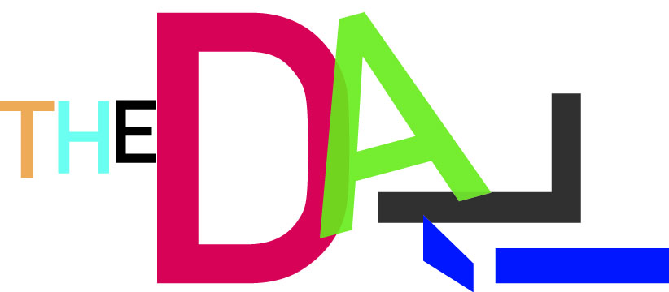

**“Change is Strange” – Pinellas County**

**EXHIBITION DETAILS**

* Open to Pinellas County middle and high school art students.
* 8”x10” finished size
* 18 award winners: Six (6) in Honorable Mention, six (6) in Merit & six (6) in Excellence
* **NEW THIS YEAR** Digital Submissions for Judging.
* 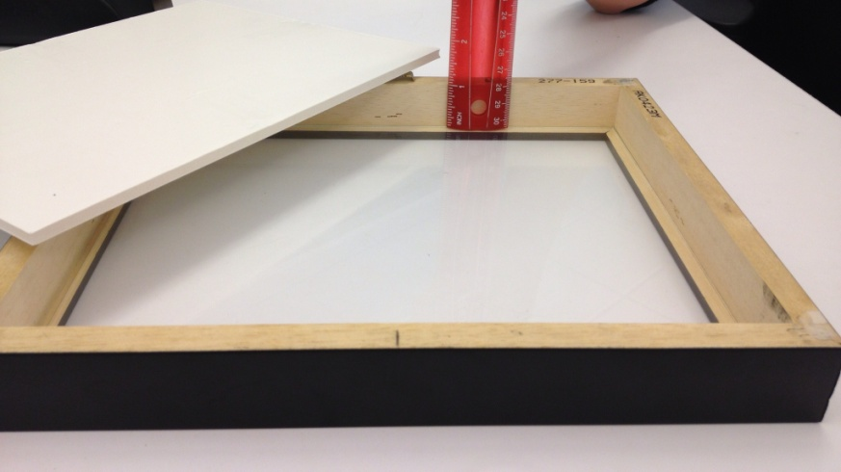Up to 8 entries per teacher - one work per student
* All artwork MUST be mounted on 8” x 10” poster board (or similar stable backing). Relief work of up to 1/2” thick will be accepted but must have 8” x 10” stable backing.
* 3/D Objects cannot be accepted for the 2014 exhibition
* Framed artwork will not be accepted
* The Dali Museum is not responsible for damage to art during transport or while at the museum
* The Dali Museum wishes to show varied work and represent as many schools as possible, so please avoid submitting similar work by different students

**ENTRY PROCESS**

* All work will be judged by digital images submitted and selected works will be delivered for exhibition
* Complete a student entry form for each image submitted. Entry form information available from the [Visual Arts Exhibition Calendar](https://www.pcsb.org/index.php?option=com_content&view=article&id=354&Itemid=815)
* **PCS Teachers**submit entries using the Student Artwork Uploader in the Art Database
* **Non PCS Teachers** submit all entry images on one CD and delivery CD and entry forms to the PCS Art Dept, 301 4th Street SW, Largo, FL 33779-2942. Phone 727-588-6057
* Before uploading images, export them from iPhoto (or similar program if using a PC) as a JPEG file, maximum quality and large size.
* Label photos correctly: “LastName_FirstName_TitleofArtwork_Grade Level” (e.g., Smith_John_SurrealDream_7).

**IMPORTANT DATES**

* December 6, 2013 Digital submissions due.
* December 13, 2013 Notifications sent of selected works for exhibition
* December 20, 2013 Artwork selected for exhibition due to PCS Art Office
* January 10-February 23, 2014 Exhibition Dates in the Dali Museum Student Gallery
* January 21, 2014 Student Reception 6:30 - 8:00 pm. at the Dalí Museum. (*Free admission extended to all student artists, their families and school personnel on night of student reception.*

**AWARDS & JUDGING CRITERIA**

Awards: two honorable mention, two merit awards, and two awards of excellence for middle school, four honorable mention, four merit awards, and four awards of excellence for high school.

|  |  |
| --- | --- |
| Level 4 | Shows strong evidence of theme.  Shows creative inventiveness and imagination.  Communicates a personal message.  Artwork is 8” x 10” mounted on poster board with NO matt  Shows excellent technical use of media. |
| Level 3 | Shows evidence of theme  Shows some creatively and personal inspiration.  Artwork is 8” x 10” mounted on poster board with NO matt  Shows good technical use of media. |
| Level 2 | Shows little evidence of theme  Artwork is 8” x 10” mounted on poster board with NO matt  Relies on appropriated or copyrighted photographic resources but is technically accomplished.  Inconsistent use of media and appears not finished. |
| Level 1 | Does not show any evidence of theme  Artwork is not 8” x 10”, NOT mounted on poster board  Relies heavily on appropriated or copyrighted photographic resources  Little or no control of media |

If you have any questions, please contact:

Bethany Mead, Education Coordinator

[bmead@thedali.org](mailto:bmead@thedali.org), or 727-623-4730

One Dali Blvd., St. Petersburg, FL 33701