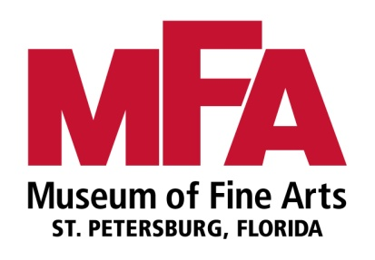 

**High School Art Exhibition**

**Sponsored by**

**The Museum of Fine Arts and DMG School Project**

**Exhibition:** Pinellas County's public and private high schools are invited to digitally submit works of art for a juried art exhibition to be held at the Museum of Fine Arts.

**Theme: Visual Metaphor**

Metaphors are comparisons used to create a heightened awareness or emotional connection to a statement or condition. Consider “raining cats and dogs” or “rollercoaster of emotions”. A visual metaphor uses images rather than words to make the comparison.

Which images would you use to create a visual metaphor? Will you illustrate or animate a metaphor that is part of everyday speech, poem, or lyric? Are there seemingly unexpected images that you can combine to create a metaphor? Will your metaphor be humorous, subtle, or severe?

**Work Specifications (submit digitally for judging)**

5-2/D or 3/D entries per art teacher (or combination of both) and

5 Movie entries per art teacher

2/D artwork:

* Artwork must be mounted and matted to exactly **16”x20”**.
* Work must be ready to frame (do not submit with a frame).
* Work on canvas must be ready for hanging.

3/D artwork:

* Work must be free-standing with a base no larger than 12” square.

Movie entries:

* Maximum length of 2 minutes submitted as a Quicktime movie on a DVD.
* Label DVD with school and teacher name. Submit DVD with a completed entry form.

Artwork that does not meet specifications will not be accepted.

**How to submit entries *(Digital Image Required for Adjudication):***

* **Complete a student entry** form for each image submitted. Entry form information available from the [Visual Arts Exhibition Calendar](https://www.pcsb.org/index.php?option=com_content&view=article&id=354&Itemid=815)
* **PCS Art Teachers**: Use the Student Artwork Uploader in the Art Database for image submission.
* **Non PCS Art Teachers**: Send all images on one CD with a student entry form for each work to Pinellas County Schools, Visual Arts Office, 301 4th Street SW, Largo, FL 33770
* **Before** uploading images, export them from iPhoto (or similar program if using a PC) as a JPEG file, maximum quality and large size.
* Label photos correctly: “LastName_FirstName_TitleofArtwork_Grade Level” (e.g., Smith_John_SurrealDream_7).

**Due Dates:** March 7 Digital Entry Deadline

March 14 Notification of selected works for exhibition

March 21 Selected works due to PCS Art Office

April 24 Awards Reception 6-8 pm at Museum of Fine Arts

April 5-27 Exhibition Dates

**Judging and Selection Criteria:**

Work adjudicated through digital entries only. Entries juried by a committee from the Museum of Fine Arts. Selection based on artistic merit, theme, originality, skill, technique, personal artistic vision and style.

**Awards:**

Awards of Excellence and Merit will be announced at the reception on April 24.

**Artwork Return:**

After the show closing artwork will be available for pick up at the PCS Visual Arts Office.

**Sample lesson plan:** <http://www.artsalive.ca/collections/posters/pdf/en/ArtsAlive_visualmetaphor_e.pdf>