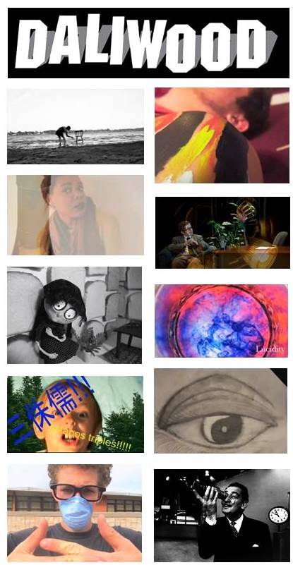
Daliwood Student Film Competition & Exhibition, 2014

Theme: Change is Strange

"I see the human form in trees, animals: the animal and vegetable in the human. My art shows the metamorphosis that takes place."- Salvador Dalí

met•a•mor•pho•sis /ˌmetəˈmôrfəsəs/

Noun
1. Familiar images are changed in form, appearance, nature, condition, character or function to become unusual or strange.

2. A change of the form or nature of a thing or person into a completely different one, by natural or supernatural means.

Synonyms
transformation - transfiguration – shape-shifting– illusion

Surrealism invites us into a world where even the most seemingly insignificant occurrences of everyday life can be transformed in order to surprise, to be made strange, shocking or even disturbing. With this year’s exhibit, we invite the students to explore metamorphosis through short film.

*Review the following pages for exhibition details, entry instructions & tips to make your students’ films effectively surreal.
Daliwood 2014 Challenge :

The Dali Museum challenges the students to employ the following elements in their films:

- Milk
- A wheel
- This line of dialogue: “I like the walrus best.”

General Information

- Open to both Hillsborough & Pinellas County middle and high school students
- Work Due: Fri, Mar 7
- Where to Send:
Pinellas County Schools Arts Office
Attn: Sue Castleman, Daliwood
Pinellas County School Administration Building,
301 4th St. SW, Largo FL 33779-2942.
Ph: 727-588-6057; Hours: 8:00 am - 4:30 pm
General Information, cont.

- Award Ceremony: Saturday, April 12 afternoon (time pending Sunscreen Film Festival)
- Dalíwood Film Exhibition: Apr 18 – Jun 2
- Award Winners: Three winning videos will receive $125; sponsoring teacher will receive $125 for their school
- For questions, contact:
Bethany Mead, Dali Museum Education Coordinator
bmead@thedali.org; 727-623-4730
Submitted Material

- Must be original work
- Running time between 30 seconds and 4 minutes. No more, no less.
- Format: 2 standard definition DVDs (4:3 aspect ratio/720x480)
- Paper DVD envelopes preferred
- Upload your completed film to YouTube using the following tag: daliwood2014changeisstrange
- Students are encouraged to use original music in their film.
- Must provide written permission to use copyrighted work, including music AND identify copyrighted information material in film credits
- DVDs must be labeled with title, name of teacher/school, student director, contact information and running time
- Must be accompanied by a completed entry form PER STUDENT DIRECTOR
- One project per DVD
- Limit 4 projects per teacher

General Judging Criteria

- All work must be original. The work must not infringe on the intellectual property rights of any other individual. If there is any doubt regarding the authorship of the work, please do not submit it. Work found to be copied will be disqualified.
- The Dali Museum welcomes strange, startling or unusual content. That said, we will not accept films with inappropriate content. This includes any violence or drug use.
- Judges will give priority to films following the theme. Visit our youtube playlists of previous years’ accepted entries
- The Dalí Museum jury panel will include two unbiased judges and Education Curator Peter Tush.
- Three awards will be given.
- All selected entries and the three award winners will be shown at this year’s Sunscreen Film Festival.
- Additionally, the films will be shown as part of the season of student art shows at the Dali Museum in the Education Gallery.
- Teachers and students are advised to spend 60% of the video’s production time in class

- Judging based on following rubric:

Level 4  4 Points | ___ Content/Theme: The content includes a clear statement of purpose or theme and is creative, compelling and clearly written. A rich variety of supporting information in the video contributes to understanding the project's main idea.  ___ Copyright: Copyrighted information for photos, graphics and music is clearly identified by source and nature of permission to reproduce.  ___ Production/Technique: Video is well planned, with smooth transitions and edits and makes productive use of length of time. Sound is excellently balanced and easy to hear. All elements coincide with the theme/content.
Level 3  3 Points | ___ Content/Theme: Information is presented relating to theme with accurate, current supporting information that contributes to understanding the project's main idea.  ___ Copyright: Every photo, graphic or music is either original or permission for its use is documented.  ___ Production/Technique: Video is well planned with competent edits. Sounds is well balanced and easy to hear. Most production elements blend with theme and/or content.
Level 2  2 Points | ___ Content/Theme: The content does not present a clearly stated theme, is vague, and some of the supporting information does not seem to fit the main idea or appears as a disconnected series of scenes with no unifying main idea.  ___ Copyright: Some sources of photos, graphics, and music are not clearly identified with references, and permission to reproduce is missing.  ___ Production/Technique: Video was somewhat planned. Transitions and edits are rudimentary. Sound is reasonably balanced. Some production elements are distracting.
Level 1  1 Point | ___ Content/Theme: The content lacks a central theme, clear point of view and message. Much of the supporting information in the video is irrelevant to the overall message. The viewer is unsure what the message is because there is little persuasive information and only one or two facts about the topic.  ___ Copyright: There is no reference to copyright information for photos, graphics, and music.  ___ Production/Technique: Video is not well planned and has poor edits. Sound is of poor quality. Many production elements distract from the theme/message.

Filmmaking Tips

The Dali Museum has screened many student films over the years. Below is a list of suggestions to strongly consider as you start the filmmaking process:

1. Consider a genre: Any genre of film may be made surreal. Examples of typical genres: drama, comedy, film noire, action, documentary, musical, western, science fiction. Have a story and stick to it.

2. Look to past student films: http://www.youtube.com/playlist?list=PLrdXfGJ6YuL67IlnBBgmABIJup0SVyL7R Playlists of 2011 and 2012 shows also live on the Dali Museum’s YouTube site.

2. Avoid copy written music! Many films are rejected each year because they use music that obviously is professional and copy written (Hitchcock soundtracks, alt bands like The Books, etc.). This is illegal and your film will not be accepted, regardless of its originality. If you can’t make your own soundtrack, then use the copyright-free music available through a Garage Band-type program. More information about the use of copyrighted material here: cybercollege.com

3. Less is more: Of the 3 films chosen in 2010, the longest was 3 minutes, the next was 2 minutes, and the final was 46 seconds. Brevity!

4. Avoid clichés: there are many standard clichés that appeared in multiple films that rendered them indistinguishable from the competition. Try to take these clichés and find a new way to present the idea. Here are two of the worst offenders:

- The real world is in color, but the dream world is in B&W
- Whenever a doppelganger appears in a dream sequence, everyone shows them wearing a mask, usually a white Venetian masquerade mask.
- Running away from something.

5. Don’t keep walking or running: If you need to walk from point A to point B, do not take us on the entire journey. Walking in film gets boring to watch.

6. Create a unique setting: If your classroom is the site for your film, make it count. Half of film entries use classrooms as the site for their film, so the story better be good or it will look generic. Consider film techniques and sets that can eliminate the look of a classroom (stop motion animation is a great way to allow for creative worlds).

7. Surrealism is not necessarily horror: Many films were simply about people running from monsters. This can be appropriate if done right, but it can also be tedious.

8. Tell one story well: This year several filmmakers didn’t know how to end a film, so they would graft on a second story. It doesn’t help. Brevity!

9. Work on scripts: The outstanding films told a story well and concisely. They had a beginning, middle and end. And dialogue when necessary was important. Having too much improvised dialogue can make a film seem haphazard, unfocused and uninteresting.

10. Check to make sure video plays and that the sound levels are not dropped: Last year there were several films that did not play properly regardless of the equipment. If it can’t be played in a DVD player, it can’t be included. And check sounds levels to ensure consistency.

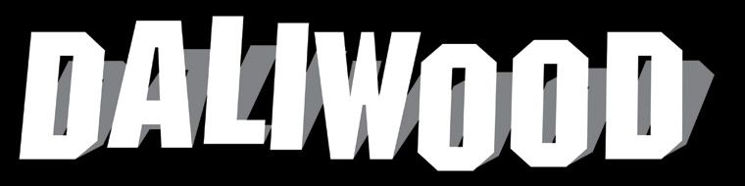

Entry Form - Please fill out one form per student director

Title of Video ______________________________________________________________Running Time _________________________
Student Director Name_____________________________________________________________________Age________Grade_______
ADDITIONAL STUDENTS INVOLVED IN PROJECT (Include any students who would be credited in the reception program. Attach a separate list if necessary. Include Ages & Grades) _______________________________________________________________________________________Age________Grade_______
Teacher Name__________________________________________________Email Address_____________________________________
Parent/Guardian (if under 18) _____________________________________ Email Address______________________________________
School_______________________________________________________ __________________________________________________
School Address___________________________________________________________________________________________________
School City,Zip________________________________________________________________ Contact Phone_______________________
All work must be executed by the student. By signing the entry form, both the students and teacher/parent have certified that the work is the student’s original, created by her or himself and does not infringe upon the intellectual property rights of any other individual or entity. Any work found to be plagiarized will be disqualified and any awards granted will be withdrawn.

_______________________________________________________________________________________________________________
Student Signature + Date

_______________________________________________________________________________________________________________
Teacher Signature + Date

_______________________________________________________________________________________________________________
Parent Signature + Date
Video Accepted___________Yes____________No

This portion will be cut off for office use-please fill out same as above.
Entry Form: Dalíwood Student Surrealist Film Competition
Title + Running Time | Time :
Student Director + School
Teacher + Teacher Email
Addtl. Student Name(s)
Work Accepted? | Yes No
Score ______ | Judge 1 Judge 2 Judge 3

