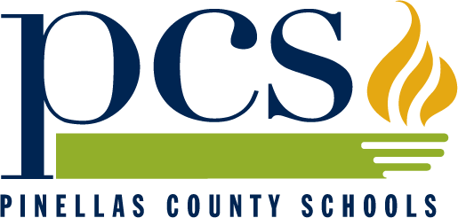
Pinellas County Schools of Florida

Middle
School
Uniform Course Descriptions

2014-2015

The School Board of Pinellas County, Florida, prohibits any and all forms of discrimination and harassment based on race, color, sex, religion, national origin, marital status, age, sexual orientation or disability in any of its programs, services or activities.

Members of the Board
Carol J. Cook, Chairperson
Linda S. Lerner, Vice Chairperson
Janet R. Clark
Rene Flowers
Terry Krassner
Peggy L. O’Shea
Robin L. Wikle

Superintendent
Michael A. Grego, Ed.D.

Associate Superintendent, Teaching and Learning
Pamela T. Moore

Executive Director, PreK-12 CORE Curriculum
Dywayne Hinds

Prepared by
The Division of Teaching and Learning

Please note: The High School Uniform Course Descriptions for 2014-2015 were approved by the Pinellas County School Board on January 28, 2014.

301 Fourth St. SW
P.O. Box 2942
Largo, FL 33779-2942
(727) 588-6000 x3069

