**Testing Flow Pressure must be 30.0 – 30.5 psi at the water inlet of the test unit**.

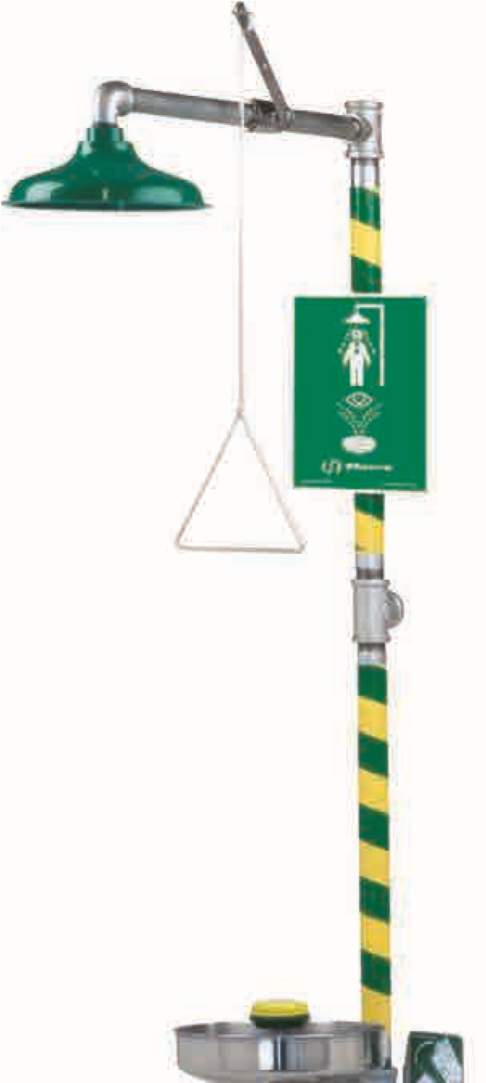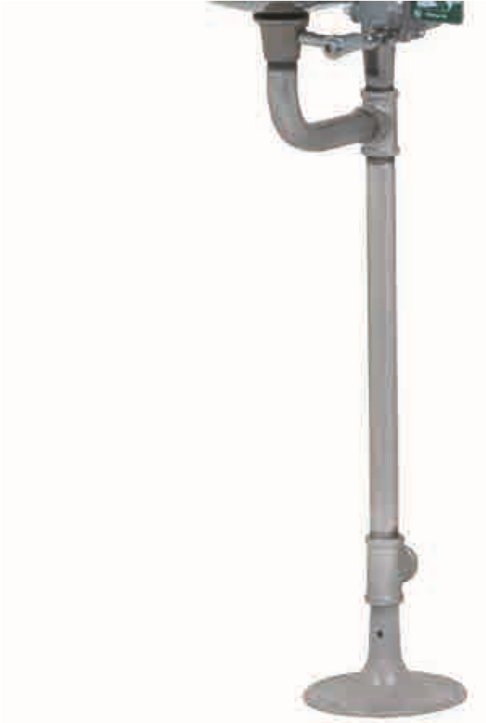

|  |  |
| --- | --- |
| **LOCATION**  Emergency equipment shall be activated ***weekly* (*w*)**. | **SHOWER**  Showerhead must be 82 to 96 inches above surface floor of user. (Sec. 4.1.3, 7.1). |
| Safety station shall be accessible within 10 seconds of hazard. (Sec. 4.5.2, 5.4.2, 6.4.2, 7.4.2) **(*w*)**. | Shower must deliver a minimum of 20 gallons per minute (gpm) and provide a column of water 20 inches wide at 60 inches above surface floor of user. (Sec. 4.1.2, 4.1.4, 7.1) |
| Safety station shall be located on same level as the hazard and the path of travel shall be free of obstructions. (Sec. 4.5.2, 5.4.2, 6.4.2, 7.4.2) **(*w*)** | Valve shall be designed so that the flushing flow remains on without the use of the operator’s hands. The valve shall be simple to operate and go from “off” to “on” in one (1) second or less and actuator cannot be more than 69 inches from surface floor of user. (Sec. 4.2, 7.2) |
| Emergency equipment location shall be well lit and identified with a highly visible sign. (Sec. 4.5.3, 5.4.3, 6.4.3, 7.4.3) **(*w*)** | **EYEWASH / EYE/FACE WASH**  Must provide a means of controlled flow to both eyes simultaneously at a velocity low enough to be non-injurious. (Sec. 5.1.1, 6.1.1. 7.1) **(*w*)** |
| **TRAINING**  All employees subject to exposure to hazardous material should be instructed in the location and proper use of emergency equipment. (Sec. 4.6.4, 5.5.4, 6.5.4, 7.5.4) | Eye/face wash equipment must deliver a minimum of three (3) gallons per minute (gpm) of water for 15 minutes. (Sec. 6.1.6, 7.1) Eyewash only must deliver minimum of controlled flow of flushing fluid 0.4 gallons per minute (gpm) of water for 15 minutes. (Sec 5.1.6, 7.1) |
| **COMBINATION UNIT** (If applicable)  Combination unit components shall be capable of operating simultaneously and shall be positioned so that components may be used simultaneously by the same user. (Sec. 7.3, 7.4.4) **(*w*)** | Outlets shall be protected from airborne contaminants. (Sec. 4.1.3, 6.1.3, 7.1) **(*w*)** |
| **DRENCH HOSE** (If applicable)  A drench hose, if present, can only be considered an eyewash - eye/face wash if it meets performance requirements in Sec. 5 and/or 6. | The flushing fluid of an eyewash – eye/ face wash shall cover the areas between the interior and exterior lines of a gauge at some point less than eight (8) inches above the eyewash nozzle. (Sec. 5.1.8, 6.1.8, 7.1) |
| A drench hose, if present, must deliver a controlled flow of flushing fluid at a velocity low enough to be non-injurious (sec. 8.2.1) | Flushing fluid flow pattern should be 33 to 53 inches from floor and minimum of 6 inches from wall. (Sec. 5.4.4, 6.4.4, 7.1) |
| **TEMPERATURE**  Safety Station shall deliver tepid flush fluid (above 60°F and below 100°F) (Sec. 4.5.6, 5.4.6, 6.4.6, 7.4.5) | Valve shall be designed so that the flushing flow remains on without the use of the operator’s hands. The valve shall be simple to operate and go form “off” to “on” in one (1) second or less. (Sec. 5.2, 6.3, 7.2) **(*w*)** |

Weekly Activation Check Performed By: _________________________________________ ___________________________

Print Name/Signature Date

**NOTES:**

1. Emergency equipment shall be shall activated **weekly**. (Sec. 4.6.2, 5.5.2, 6.5.2, 7.5.2)
2. All shower units shall be inspected **annually** to assure conformance with ANSI Z358.1 (Sec. 4.6.5, 5.5.5, 6.5.5, 7.5.5)
3. Information Source: Haws. [www.hawsco.com](http://www.hawsco.com)