|  |  |
| --- | --- |
| Revision History | |
| Revision Date | Section / Nature of Revision |
| 03/01/2017 | Document Issued |
| 7/20/22 | 3 J. 2) Added PRO-TECH ALL flooring adhered to metal skin  3 M. 2) Added ESP  3 M. 3) Added Each evaporator requires data line to be run to ESP controller  3 P. 1) Added Last sentence about evaporator drain lines |

## PART 1 - GENERAL

A. GENERAL SPECIFICATIONS:

Designing stage of new location back side of box be on an exterior building wall for all penetrations to go through rear wall panels with condenser pad and drains being on other side of wall for short refrigeration line set runs Walk in refrigeration equipment shall be Trenton Refrigeration with ESP Plus controller on the evaporators if box manufacture does not supply Trenton refrigeration equipment must have Trenton Factory Reprehensive size and price for purchase by the awarded equipment dealer.

Walk-in specified shall be prefabricated modular construction. It shall be designed and constructed to allow fast and easy field assembly, disassembly, relocation and enlargement by the addition of like modular panels. Walk-in shall be designed and constructed as shown on plan. Overall size of walk-in shall be actual dimensions to fit exact job site requirements.

B. PANEL CONSTRUCTION:

1) Wall and ceiling panels will be up to 46” width in 1-inch increments with 90 – degree 12-inch x 12- inch corners. All like panels to interchangeable for easy and quick assembly. Partition panel to be made in 1-inch increments to fit shelving layout.

2) Floor Panel fabricated similar to wall and ceiling with ¾-inch plywood foamed in place between 14-gauge bright galvanized interior skin and outer skin for stronger support 1200 lbs. per square inch and to support ¼-inch vinyl floor overlay.

3) Panels shall be formed specified metal pans to precise dimension foamed in place urethane insulation to bond permanently to both exterior and interior inner skins. Panels should not have internal wood, metal, straps or any other non-insulated material. Panels to have 100% urethane foam with perimeter structure consisting of formed high density urethane (Durathane) tongues and groove to assure vapor and airtight joint and to prevent installation damage. With NSF listed double-bead vinyl gasket shall be applied to the tongue side of all panels, on both interior and exterior. Gaskets shall be impervious to stains, grease, oils, mildew, sunlight, etc.

C. QUALITY ASSURANCE:

The installer must provide a certificate confirming they are factory trained and have full knowledge of proper installation procedures.

D. WARRANTY:

Panels shall carry a 10 year are longer Factory Warranty even if box is relocated.

PART 2 – PRODUCTS

Basis of design shall be Thermo-Kool, Mid - South Industries, Laurel, MS.

PART 3 – ERECTION/INSTALLATION

A. INSULATION:

1) Insulation shall be 4” to 5” thick rigid, zero ozone depleting HFC 134a blown Class I urethane foam classified according to UL 723 (ASTM-E-84) as tested by Underwriters Laboratories, Inc. The core material has a flame spread of 25 or less and a smoke density of 250.

2) Panel thermal conductivity (K factor) of 0.13 BTU/hr./sq.ft. Per degree Fahrenheit/inch in accordance with ASTM C 518-2004. K factor of 32 or higher.

3) The prefabricated urethane foamed panels shall be supplied with a Class I fire hazard classification according to UL 723 (ASTM-E-84) as tested by Underwriters Laboratories, Inc. Panels shall have a flame spread rating of 25 or less and bear a certifying Underwriters Laboratories, Inc. label.

4) This rating is not intended to reflect hazards presented by this or any other material under actual fire conditions

B. METAL FINISHES:

1. Exterior non- exposed panels to outside climate outside box panels will be 20-gauge stucco embossed stainless steel.
2. Exterior non- exposed panels inside building will be .040 stucco embossed stainless – steel
3. Exterior panels exposed to interior of building will be 20-gauge type 304 #3 finish smooth stainless steel with 20-gauge type 304 #3 finish smooth stainless-steel V shape bumpers 2-inches deep mounted on wall at 34-inch height from finished floor.
4. Interior ceiling and wall panels will be white smooth aluminum.
5. Interior floor panel will be 14 gauge bright galvanized

C. PANEL LOCKING ASSEMBLIES:

Use of an Insta-Lock cam-action hook arm assembly in one panel and a self-centering, self-aligning pin in opposing panel. Rotation of the cam action hook and arm inside box access point to pull and lock panels together for a vapor and air tight seal then access point covered with vinyl snap in covers. With a minimum of three on vertical panel.

D. PANEL GASKETS:

A National Sanitation Foundation listed double-bead vinyl gasket shall be applied to the tongue side of all panels, on both interior and exterior. Gaskets shall be impervious to stains, grease, oils, mildew, sunlight, etc.

E. ENTRANCE DOOR:

1) Door will be located in exact location in drawing and be 36-inch x 78-inch flush mounted with a 14-inch x 14-inch double pane with air gap between panes tempered safety glass PEEP Window with heated frame.

2) Door shall be equipped with a one-piece perimeter PVC accordion type removable gasket with magnetic core at the top and along the side perimeter of the door. An adjustable wiper gasket shall be mounted along the bottom edge of the door.

3) Latch shall be Kason 1236C lever locking handle with cylinder lock and inside safety lever release handle so the door can be opened from the inside even if locked. A positive action hydraulic door closer shall be included to ensure gentle closing action of door to opening and to ensure positive closing of door. The latch shall be of high pressure zinc die cast with highly polished chrome finish.

4) Three (3) hinges per door with top hinge spring loaded and shall be nine inch modified strap, cam-lift, self-closing design with door lift off capability of high-pressure zinc die cast with highly polished chrome finish.

5) Door frame shall consist of heavy reinforced steel “U” channel frame to encompass entire perimeter of opening, foamed-in-place to give extra support and rigidity to frame and to prevent racking, distortion, warping and twisting. A backup must be welded for added strength.

6) An armored anti-sweat heater cable shall be run in a breaker strip located behind a removable heavy gauge stainless steel trim for easy access to heater cable. Heater cable shall be run under threshold consisting of heavy reinforcement “U” channel breaker strip and heavy gauge stainless steel threshold. The freezer has two armored anti sweat heaters ran in the same manner as the cooler, one to be energized the other to be used as a backup for servicing benefit.

7) Door section shall be provided with a lighted operating toggle switch and pilot light mounted on the exterior side of the door frame. A Kason 1806 LED vapor proof light and face mounted inlet box shall be mounted on the interior side of the door frame for 115-volt, 60 cycles, 1 phase A.C. service. All wiring shall be in concealed rigid conduit. A Kason 1832-4 heated relief vent, 115 volt with concealed wiring shall also be provided, along with glow in the dark emergency exit lever or plunger. A 2-1/2” diameter chrome face, flush mount, dual reading, adjustable dial thermometer shall be provided on exterior of door section to provide temperature reading of -40 degrees C to +150 degrees C.

8) All interior boxes are to be trimmed out with 20 gauge stainless-steel, all exterior boxes are to be trimmed out with aluminum.

F. VINYL STRIP CURTAINS:

To minimize infiltration of air when doors are open, 4” vinyl strip curtains shall be provided on all exterior doors. Partition doors do not require a strip curtain. Required to meet current approved Florida Energy Code requirements.

G. TREADPLATE KICKPLATES:

Doors shall have 1/8” aluminum diamond treadplate kickplates and jamb guards 36” high on the interior and exterior. Diamond treadplate kickplates shall be mounted with adhesive and sealed with silicone. No external fasteners such as screws or pop rivets shall be applied as fastening for the diamond treadplate kickplates.

H. LED LIGHT FIXTURES:

Lights to be Electra 4200K or equal number of lights determine by engineer and wired together concealing wires in schedule 40 PVC electrical conduit and components.

I. HEATED PRESSURE RELIEF VENT:

Cooler and Freezer shall be equipped with a two-way heated pressure relief vent to equalize pressure between the interior and exterior caused by defrost cycles and opening of door. Electrical service to be 115v/60/1 phase.

J. FLOOR CONSTRUCTION:

1) Walk-in floor shall be fabricated similar to other panels and be designed to withstand uniformly distributed stationary loads of 1200 lbs. per square foot.

2) The galvanized steel floor will receive Contractor supplied ¼” vinyl matting (PRO-TECH ALL flooring or equal that adhered directly to metal skin). Installation of matting provided and warranted by others.

K. SLOPED WEATHERCAP:

1) For weatherproof/outdoor application, the walk-in shall be provided with a single-ply vinyl weather cap. The weather cap shall consist of a waterproof, durable, high-tenacity fabric membrane. Weather cap shall overlap walk-in panels or turn up at building wall 6” on all sides. A fascia bar with cover shall be provided to secure weather cap to walk-in. Sloped foam consisting of expanded poly-styrene and a 4-mil polyethylene slip-sheet shall be provided with weather cap. The polyethylene shall be installed between the vinyl weather cap and the sloped foam. The sloped foam roof is necessary to provide proper drainage from the top of the walk-in. Sloped foam roof shall start at ¼” thick and increase a thickness of ¼” every 11-1/2”. All installation hardware, trim and flashing shall be provided to secure weather cap to walk-in and against building wall as shown on detail.

2) Interior ceiling support shall be supplied using concealed post in the walls and an I-beam across 16’-0” length of walk-in.

L. HURRICANE PACKAGE:

Hurricane wall anchors and support package shall be provided to meet Florida Building Code. Once project has been approved and placed into production, Thermo-Kool will provide stamped engineered drawings.

M. REFRIGERATION:

1. Basic refrigeration components shall be by Trenton Refrigeration with semi-hermetic compressors type, 208 / 240-volt 3 phases. Condensing units shall be factory assembled and UL approved. The condenser shall be air-cooled. Refrigerant for each system shall be R404-A. The shall be a non-fused quick disconnect within 3 feet of unit or per code. The freezer condensing unit is to have a mechanical defrost timer and separate contactor for heater. All condensing units are to be bolted to an aluminum channel stand 18 inches high. All condensing unit cabinets are to have a powder coating to keep the unit form oxidizing. All condensing units are to have a 36-inch clearance on all sides from walls and equipment.

2) Evaporators COOLER AND FREEFERS shall be forced air type with air flow parallel to the walk-in ceiling. Evaporators shall be a standard low-profile ESP series mounted 18 inches from the wall on 3/8-inch nylon rods and hardware. All evaporator coil components shall be housed in heavy gauge aluminum housing and be equipped with the Trenton ESP+ controller. Units shall have drain pan with drainpipe connection.

3) Evaporators shall be equipped with an automatic electric defrost system including coil heaters, time clock on freezer, fan delay control, drain line heaters and liquid line solenoid. **Each Evaporator requires a data line to be ran for the ESP controller**

4) The basic components shall be supplied as specified Remote Preassembled and shall include condensing unit, evaporator coil, control kit (pressure control, thermostat, liquid line drier, sight glass, suction line vibration eliminator, expansion valve and evaporator coil mounting kit), defrost timer, fan delay control and liquid line solenoid. All parts shall be factory mounted.

5) Remote Preassembled system requires tubing, electrical hook-up, drain line and refrigerant charge supplied by qualified refrigeration, electrical and plumbing contractors.

6) All external low pressure refrigerant lines shall be incased in 1” walled armaflex insulation and wrapped in an aluminum jacket to the unit penetration.

7) A low ambient kit and weatherproof housing shall be supplied with condensing units. The low ambient kit shall consist of a crankcase heater and headmaster valve.

8) Walk-in cooler evaporator to be 115 volts, single phase. Freezer evaporator shall be 208/240-volt, single phase with all control voltage being fed from condensing unit.

N. BOX INSTALLATION SPECS

1. Inside walk in to be installed in a 4-inch deep concrete pit level floor from finish floor grade for the 4” floor panel to be level with finish floor and threshold to extend minimum 1-inch onto finish floor.
2. Requires 2-inch air gap between building wall and walk in panel walls.
3. Vapor barrier (15-pound asphalt paper or 6 mil plastic sheeting) to be installed between floor panels and concrete.
4. Walk in to be leveled with asphalt shingles
5. Box assembly to be performed exactly per manufactures installation manual installing panel per manual and tighten of cam locks in order per manual.
6. Doors are to be squared and level all hardware to align.
7. There should be no penetration threw roof panels other than Nylon Rods for hanging evaporator unless directed by PCSB Food & Nutrition personal.
8. All protective plastic coating on panels to be peeled back from edge and all panels installed then protective coating removed to prevent scratching of panels and cleanness of panel.

O. REFRIGERATION LINES:

1) All refrigeration lines will be run with type K copper and all joints, elbows and other fitting to be hard soldered in and vacuum pulled and set in vacuum for 12 hours or overnight before charging with 404a refrigerant.

2) Suction line will have a P-Trap installed inside at the evaporator

3) Suction lines will be insulated with minimum 1-inch Armor Cell part # IPPFT07810 all 90 degree turns Armor Cell will be miter cut for clean fit and all joints glued with Armor Cell 520 Adhesive.

4) Refrigeration lines penetrating walk in wall or walk in wall and building wall will be sleeved with Schedule 40 PVC pipe that’s been sprayed foamed in or silicone in leaving 1/8- to ¼ inch protruding past wall and void will be filled with Great Stuff spray foam with stretching Armor Cell up over PVC pipe and sealing to walk in panel wall and building wall access foam being neatly trimmed off.

5) Liquid line runs through schedule 40 PVC that’s been sprayed foamed in or silicone in and void filled with Great Stuff insulated foam and neatly trim off access.

6) Strapping refrigeration lines to walk in wall, building wall and ground to done by using Kendorf Supper Strut SS 12 Gauge A-1200-SS and HYDRA SORB CUSION CLAMPS.

P. DRAIN LINES:

1) Drain lines to be ran independent in Type K copper with a union soldered on inside box at evaporator within a foot of the evaporator all other connectors will also be solder and penetration threw walk in panel and building wall needs to be sleeved with silicone or foamed in place schedule 40 PVC pipe and void filled in with Great Stuff Insulated spry foam. Evaporators drain lines to be piped directly from drain pan thru walk in and building wall leaving exposed, no drain line run should be between walk in wall and building wall making it un-assessable for service.

1. Freezer drain will have a heater wrapped around pipe from evaporator to point where it exit the box and insulated with a minimum of 1-inch Armor Cell insulation. Heater is not to be wired in to control circuit is to have a 115-volt outlet on wall behind evaporator to plug heater in.
2. There is to be no PVC pipe used for the drain itself in either cooler or freezer.
3. Strapping refrigeration lines to walk in wall, building wall and ground to done by using Kendorf Supper Strut SS 12 Gauge A-1200-SS

Q. ELECTRICAL:

1. All conduit from exterior of walk in panel and inside walk in be ran in schedule 40 Electrical PVC.
2. All penetration into box be sealed and after wire is ran inside of pipe to be filled silicone or spray foam insulation to prevent condensation.
3. In freezer there will be 115-volt outlet on wall behind evaporator and wired in off light circuit before light switch.
4. Freezer evaporator electrical control circuit be run from condensing unit with 2 spare wires all wires be different colors.
5. Lighting wires will be run in schedule 40 PVC
6. Strapping refrigeration lines to walk in wall, building wall and ground to done by using Kendorf Supper Strut SS 12 Gauge A-1200-SS

R. NSF CONSTRUCTION:

The walk-ins provided in the above specifications shall be constructed in accordance with National Sanitation Foundation, Standard No. 7. The NSF approval seal shall be affixed to the serial plate of the walk-in.

S. QUALITY INSPECTION REQUIREMENTS:

Walk-ins shall be set up at the manufacturer’s facility prior to shipment and a quality control inspection performed on the product. A digital photograph of the walk-ins set up at the manufacturer’s facility shall be provided for the Food Equipment Contractor’s permanent records.

T. INSTALLATION, OPERATION AND MAINTENANCE INSTRUCTIONS:

* 1. The walk-ins shall be supplied with a complete set of the approved manufacturer’s installation, operational and maintenance instructions to cover erection of the walk-in, installation operating procedures and routine maintenance schedule.
  2. The installer must provide a certificate confirming they are factory trained and have full knowledge of proper installation procedures.
  3. The installer is responsible for the handling, storing and protecting of walk-in per the manufacture’s manual to prevent any damage to panels or incomplete install that may occur from the environment.

U. DETAIL IMAGES:

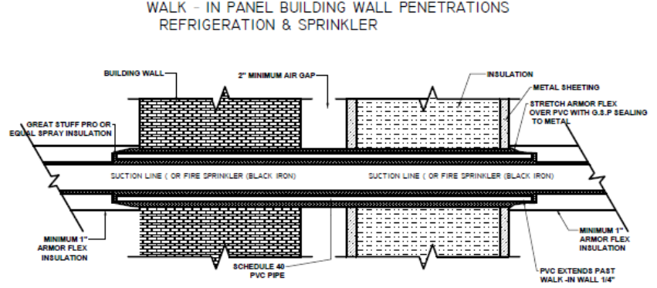

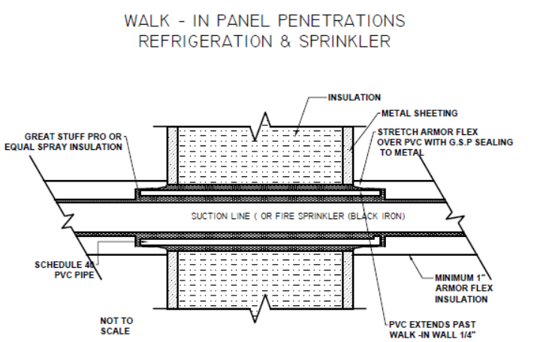

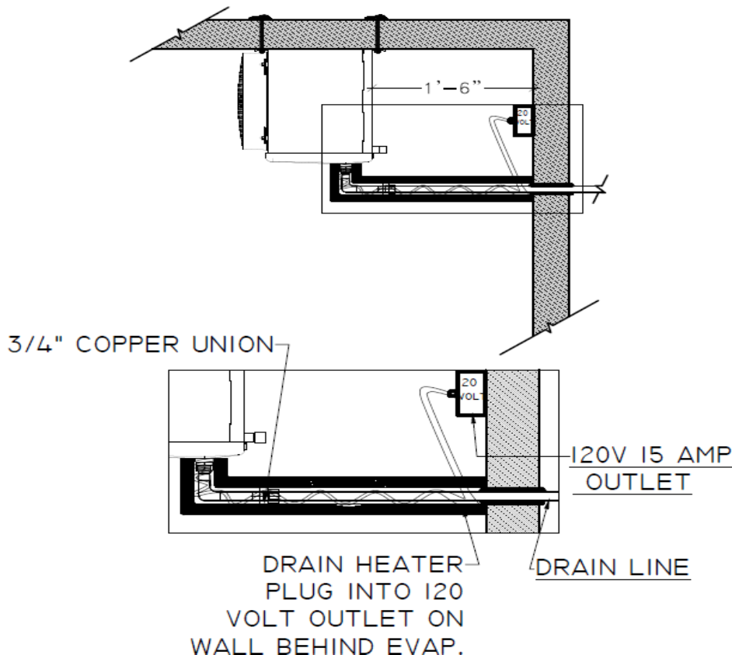

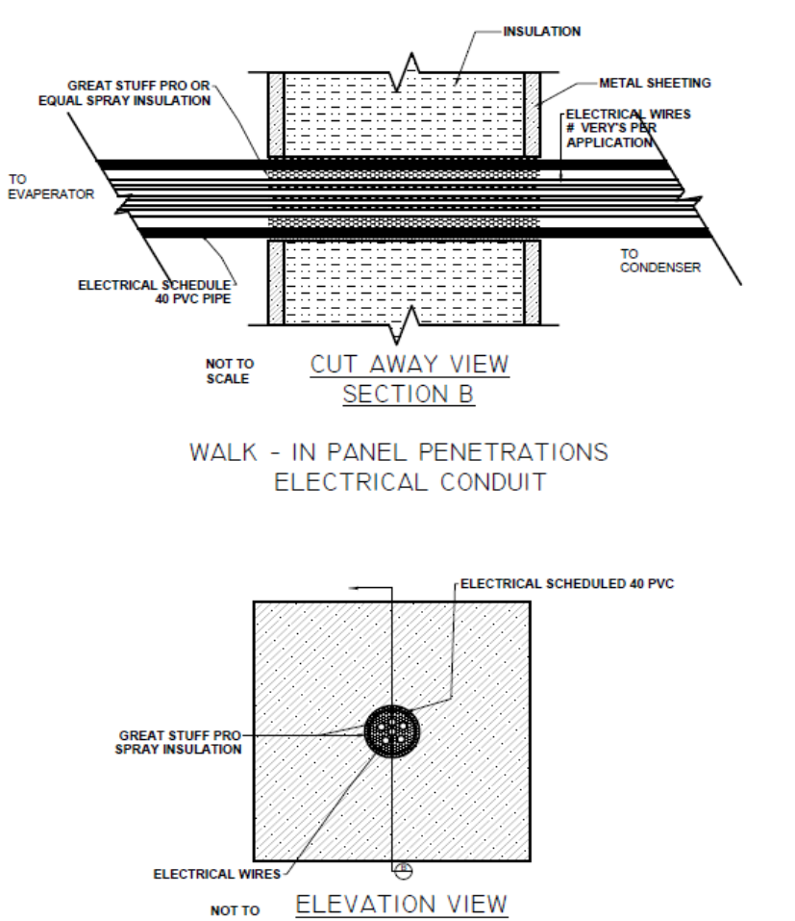

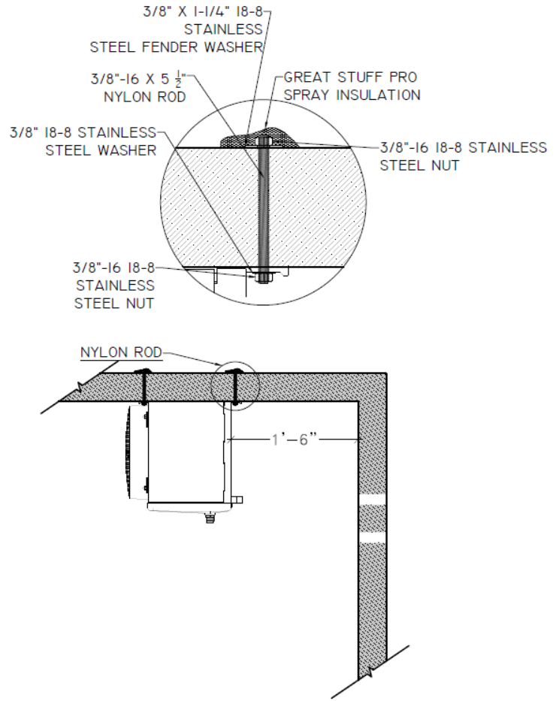

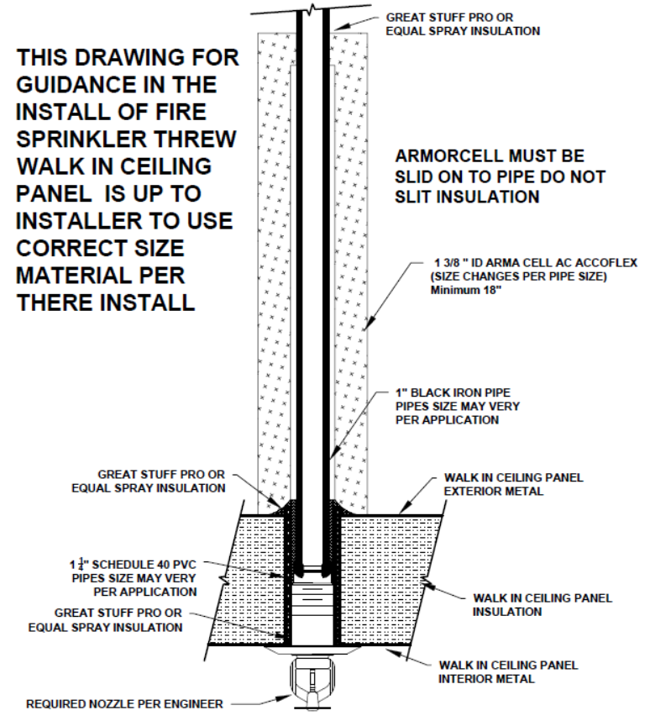

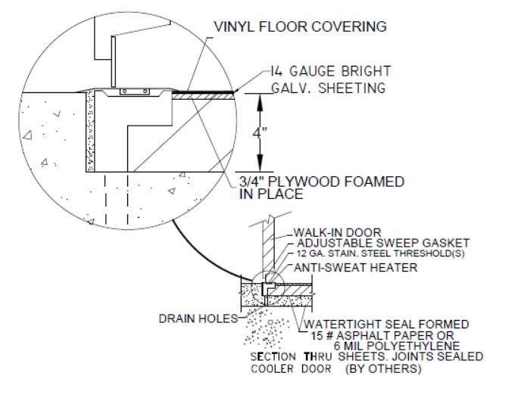

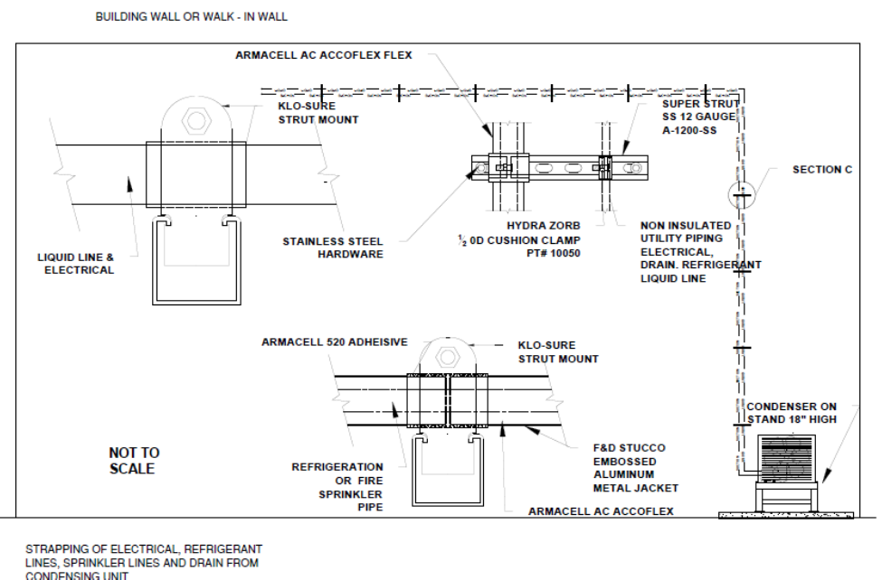

**END OF SECTION**