SAC Meeting Minutes 1/22/25

- Meeting called to order at 5:18pm (Tammy Kaplan, President of SAC was out sick, led by Mr. Jones)
- Attendance was captured via QR code Log-in
- State of the School:
  - Goals include: 1) High Quality Tier Instruction for all Students, 2) Closing the Academic Gap between Sub-Groups and general population focusing on Black and ESE Students, and 3) Improving the school culture and environment
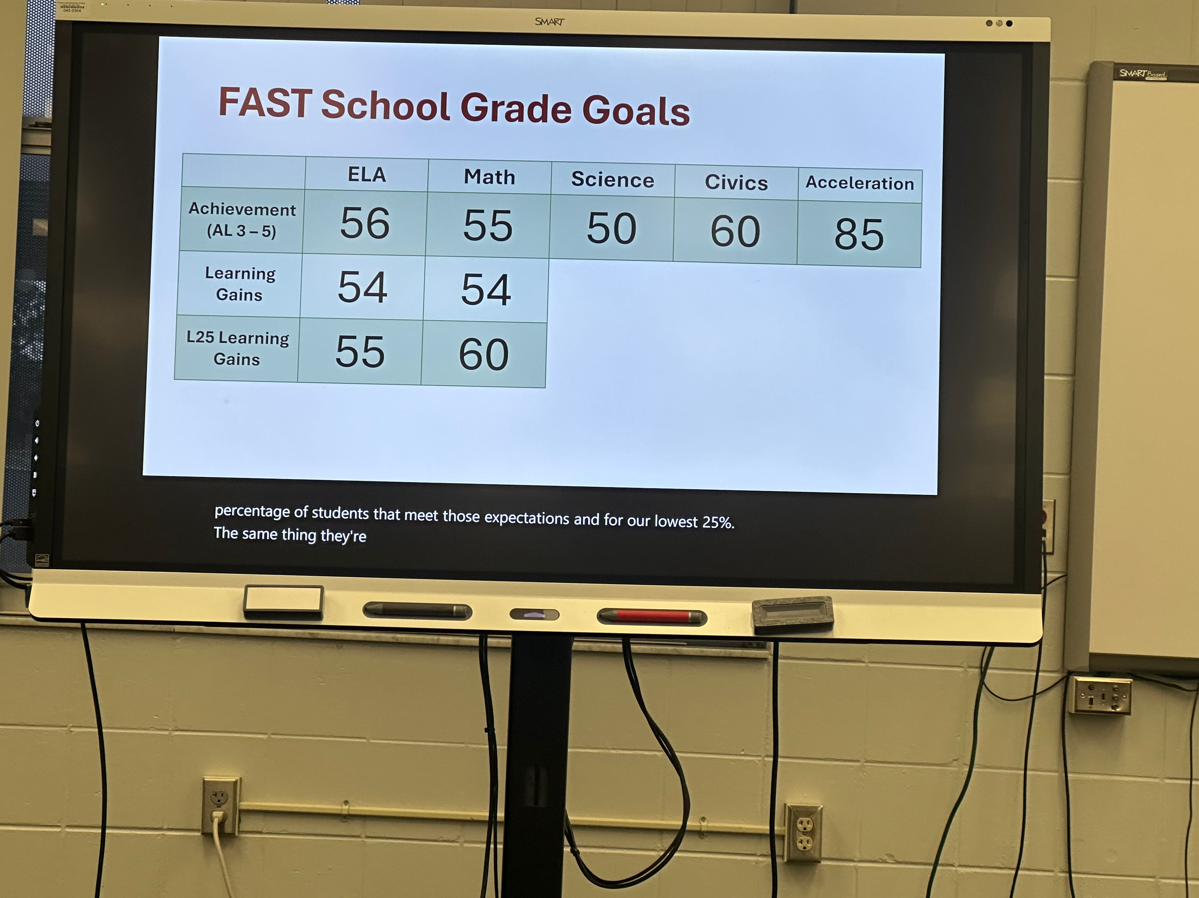
  - Review of FAST Goals
  - Review FAST PM2 Data:
    - ELA Scores look relatively good and we are on track to meet our goals. We need to work on Reading Informational Texts and Math and Social Studies teachers are going to work to support ELA in this. We also will be doing reading intervention with our L25 students in Reading Classes.
    - Math Scores are not as good as ELA we are farther from our goal and need more support to get there. We are having all of our teachers do more professional development, we will promote the us of iXL for all of our students to reinforce learning, we are supporting teachers to re-teach topic areas in the classroom where students fell short, we are bringing students in to Data Chat conversations so they are more familiar with their goals, and we have intervention group pull-outs in math happening for our L25 students starting in March
    - Discussion surrounding how parents and families can support math efforts at home and how we can provide information to our after school program providers about what we need our students to be focusing on when it comes to Math.
- Decision was made to push the Gallery Walk to the following meeting since our SAC President was not present.
- Meeting dates for the rest of the year are: March 4th 5:30-6pm (immediately followed by PTSA 6-7pm) and April 15th 5:30-6pm (immediately followed by PTSA 6-7pm)

