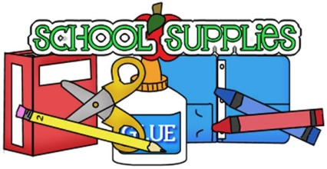
Northwest Kindergarten Supply List

School supplies:

- Full sized backpack (no wheels)
- Change of clothes (to be kept in backpack)
- Headphones or earbuds

Please make sure that your child’s first and last name are printed on all items above.

Optional supplies:
- Hand sanitizer
- Healthy snacks (see Wellness guidelines)
- Clorox wipes
- A box of tissues
- Black dry erase markers

All items are optional and if you need assistance with any of the school supplies, please reach out to your child’s teacher. Please do not label the optional or wish list items with your child’s name.

Wish list:

- Avery labels (all sizes)
- Paper plates (all sizes)
- Copy paper (any color)
- Cardstock (any color)
- Envelopes
- Treasure box items (small toys)
- Play dough
- Stickers
- Paper lunch bags (any color)
- Sharpie markers
- Chalk markers
- Band Aids
- Multi Surface Spray Cleaner
- Ink pens
- Ink pads
- Laminating pouches
- Post-it Notes (any color)
- Sheet protectors
- Foam letters or shapes
- Dixie cups (small)

Items on our wish list are things that teachers purchase or that we use on a regular basis in class.
We may also request additional supplies in our monthly newsletters.
Donations are always welcome and greatly appreciated!


