1st Grade School Supply List
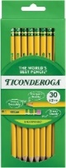  2 packs of Ticonderoga Brand  #2 pencils  (pre-sharpened) | 2 boxes of Crayola 24 crayons  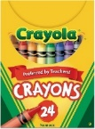 | 2 packages (3-count +) ELMER’S glue sticks  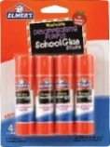
4 composition books  WIDE RULED  (Black, Green, Yellow, Blue)  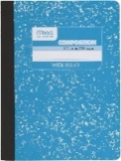 | 2 packages of EXPO BLACK dry erase markers  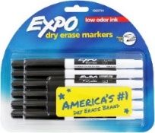 | 1 three ring binder (1 inch) with pockets & clear front plastic pockets  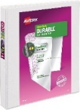
Headphones with microphone  (to keep at school)  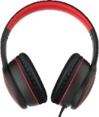 | Clorox wipes  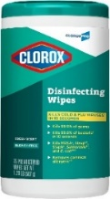 | 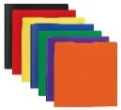  5 plain PLASTIC folders prongs & pockets (red, green, black, blue, yellow)
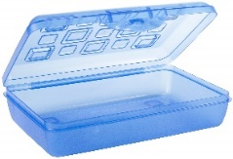  1 plastic pencil box (7 ½ inches by 4 ½ inches) | 1 pair of Fiskar round-tipped scissors  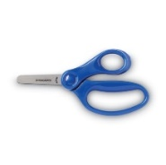 | 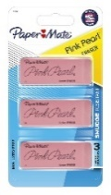  1 pack of large erasers
Please do not label any of the supplies with your child’s name,
as we use the supplies as a classroom community throughout the year.
Wish List Items
*If you are able to donate 2-3 of the below items, we would greatly appreciate it.
- Large bottles of anti-bacterial hand sanitizer
- Boxes of Kleenex tissue
- Boxes of snack sized Ziploc bags (boys)
- Boxes of gallon sized Ziploc bags (girls)
- Band-aids

