Oak Grove Middle School
Tutoring (ELP) & Course Recovery | 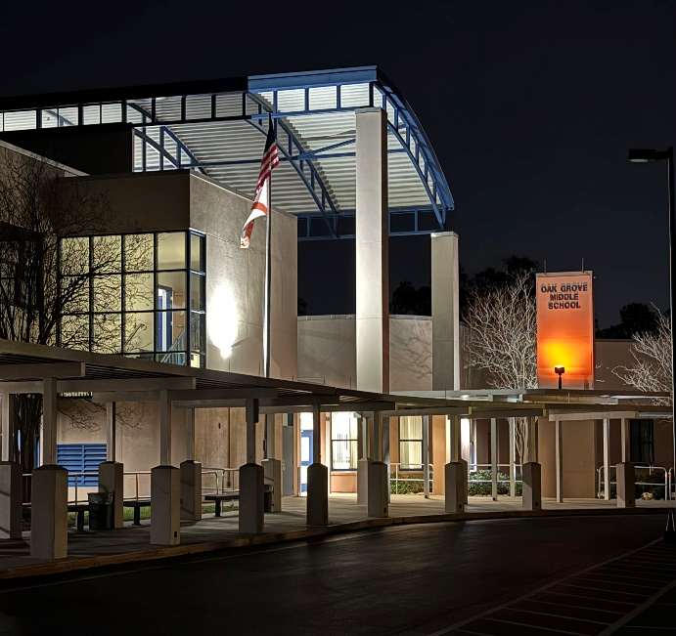
Before & After School Tutoring, Course Recovery and Enrichment is Provided at Oak Grove Middle School | *Must provide transportation  *Academic support and enrichment offered in Math, ELA, Science, Civics and ESOL  *Drop-off & pick-up located in front of the school
Before School:
Monday, Wednesday and Friday 8:15am-9:15am

After School:
Monday, Tuesday, Wednesday and Thursday 4:15pm-5:15pm
Tutoring and Course Recovery will begin on Monday, August 25th

