**K/1 ASD – Ms. South**

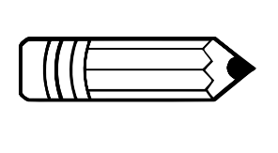Classroom Supply/Wish List

Supply List:

* 1 inch binder (any color/pattern)
* Crayons
* Glue sticks
* Scissors
* Black skinny expo markers
* A change of clothes to keep in the classroom (including underwear and socks) – please label with your child’s name
* Pull ups and wipes (as needed)
* Snacks for your child during snack time
* Water bottle for your child to drink out of – please label with your child’s name

Wishlist:

* Tissues
* Hand sanitizer
* Disinfectant spray
* Disinfectant wipes
* Ziploc bags
* 1 package plain white copy paper
* Individually wrapped snacks for the class