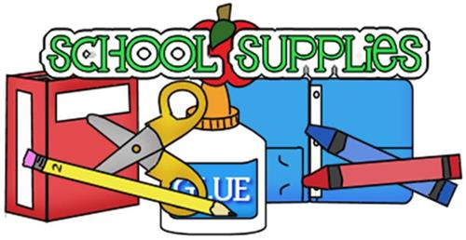

SAWGRASS LAKE ELEMENTARY  
2nd GRADE

* 2 packs of plain yellow #2 pencils sharpened

* 1 box of 16 count crayons and colored pencils

* 6 glue sticks

* 2 bottle of hand sanitizer

*2 container of Lysol wipes and/or Lysol spray

* 2 boxes of Kleenex tissue

* 1 Pencil box

* 1 plain white **1½ inch** 3 ring binder with a clear outer layer

* 2 black composition notebooks (Math)

* 2 green composition notebooks (Science Journal)

* 1 red 3-pronged folder with pockets (Writing)

* 1 orange plastic folder without prongs (Homework)

* 1 pencil pouch for binder

* 1 ream of computer paper

* 1 pack of lined notebook paper

* A pair of headphones with microphone

* A pack of dry erase markers