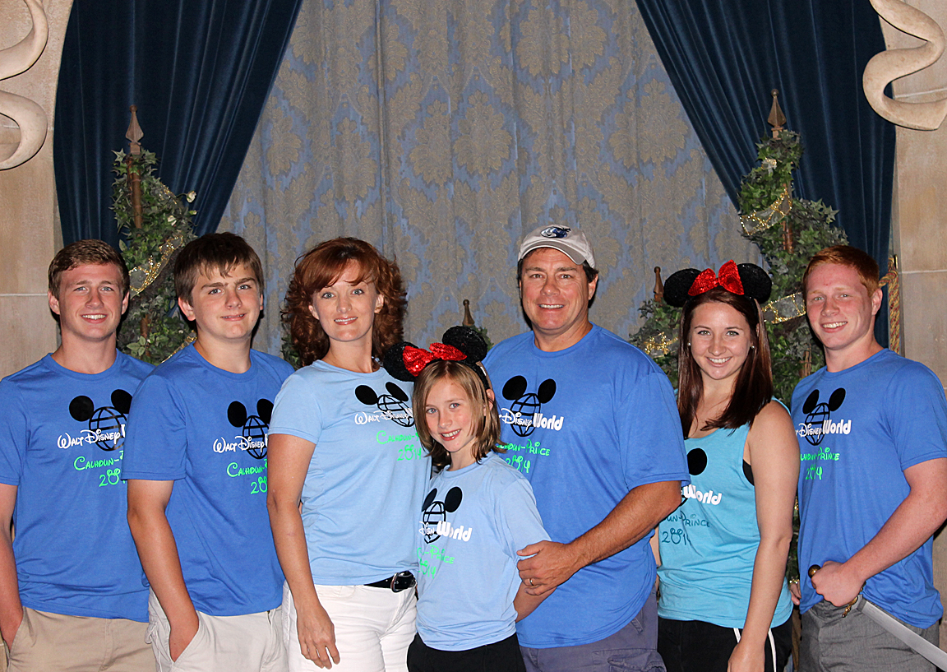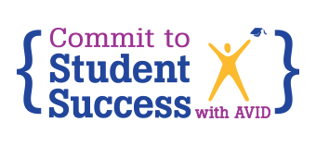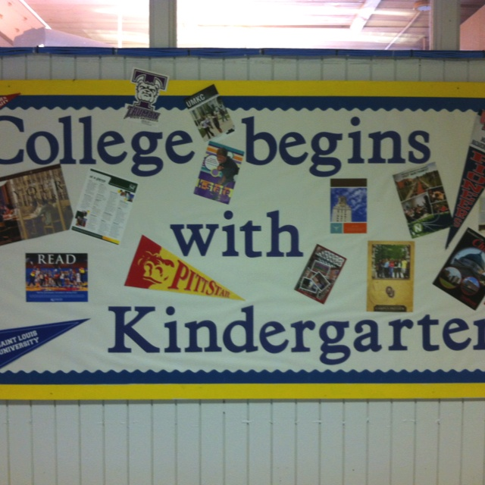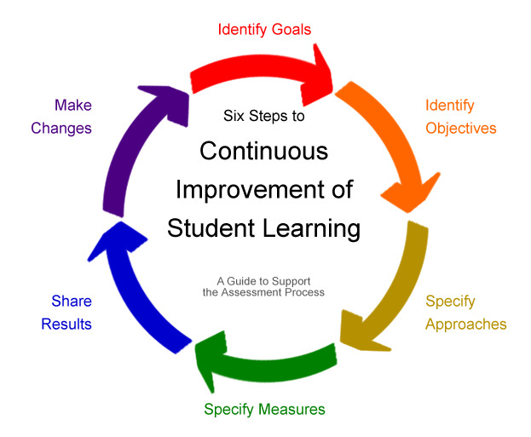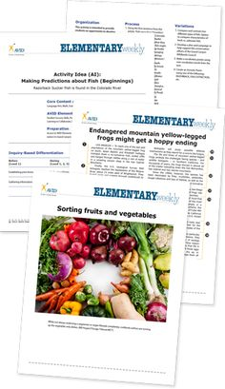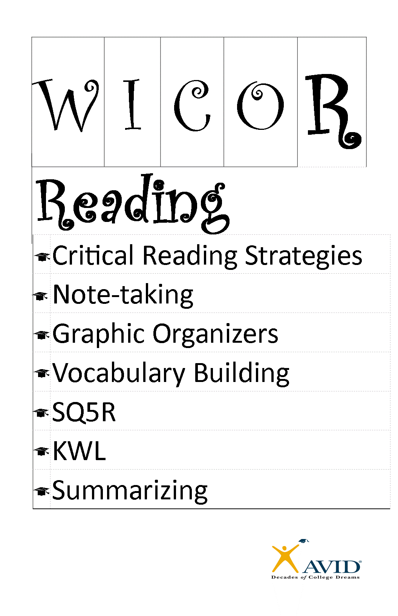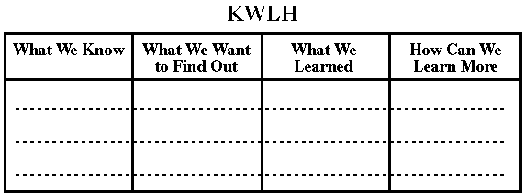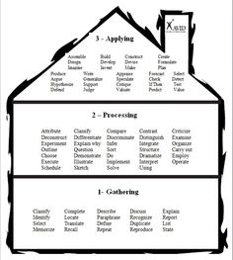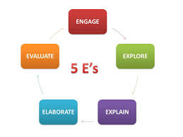

Due: 9/24/14

10/30/14

10/31/14

##### AVID Center Site Visits

This month the site visits focused on where you are now and the site priorities plans. We also went over how I can best assist the staff at your school to move AVID forward this year.

Goal Setting and Planning is the focus this month! The more specific your plans are the better.

I am also part of the ISM team. I will be at as many visits as I can. At those visits I will be looking for how AVID is integrated into the school environment, and how the core content and AVID connect.

# Site Visits

Spreadsheet Attached

Forms attached

##### Site and Grade Plans

Due: 9/26/14

Due: 9/26/2014

##### Initial Student Data

I have really enjoyed getting to see what you are working on in your schools. Seeing AVID in action is so exciting! During the school visits I have seen evidence of high student engagement, note-taking, and AVID lessons about student success.

A little about me: In my previous life I taught AVID, English, and Reading at Palm Harbor University. My background is ESE and Elementary, but life had other plans! I started the AVID program at PHU with 10 students and there are now over 200. I am also an AVID Staff Developer for AVID Summer Institutes across the country.

When I am not living the AVID life I am chasing my 5 children across the state. My wild Prince’s are active athletes, theme park enthusiasts, and AVID kids. We are an AVID family!

I am can’t wait to work with all of you!

### Welcome!

Pinellas AVID-E

District Director of AVID Elementary Kerrale Prince – [Princeke@pcsb.org](mailto:Princeke@pcsb.org)

Cell – 727–455-2944

September 2014

#### Save the Date!

**Have the initial student assessments been conducted? Do you need assistance with this?**

What data is your site monitoring in order to drive student instruction?

How are you using the results of content area assessments with AVID to increase rigor?

**Begin the ISS and School Data Reports.**

Data and Assessment

How is your school creating a college going culture?

Do you have any family workshops scheduled?

What service learning/college/career activities do you have planned?

How will AVID, the site behavior plan, the SBLT team, and your LLC team work together?

What is your school wide focus for this year?

Which AVID strategies are being used at each grade level?

What type of training or materials do you need?

Who is disseminating the school wide goal?

School Wide Focus

Review the site priorities documents as a site team:

Are the goals specific? Is there a timeline for success? Have steps been implemented to reach your school wide goals? Did your site create SMART goals?

Who will manage the progress of each goal?

What are the responsibilities and roles of the site team?

Have you set the calendar for all site team meetings?

How are you celebrating site success?

## Site Priority and Grade Level Plans

# September To Do’s

School Climate and Culture

# AVID Weekly

**Recommended this month:**

**Reading and Writing: Making a Difference. This lesson includes an article and a visual with a WICOR lesson. The students will love the Superhero window washers!!!!**

Easy to use lessons to increase reading comprehension and literacy that are aligned with AVID methodologies and Common Core expectations.

Lessons for June and September are up and ready to go! Includes a bonus lesson from June.

**Activating Your Subscription**

My recommendation is that you make a general account for your school that everyone can use.  You have 20 subscriptions to utilize this year.

Go to [http://www.avidelementaryweekly.org](http://www.avidelementaryweekly.org/)

There is a green tab that is labeled Activate a Subscription.  On that page it will ask for your activation code (these were sent out to the Principal from me).

Then agree to terms, and fill-out the following information:

Example of a general usage could be username:  (School Name)14 and password (School Mascot)14

The username must have a unique character in it and cannot be more than 12 words.

Enter the school address and an email address for the main contact.  This is only for setting up the account.

###### Each Month 12 New Lessons are Uploaded. Beginnings K – 2, Foundations 3 – 5, Bridges 5 - 6

# Lesson Focus

Incorporate AVID Weekly into your planning. The lessons are all based on the new standards and expectations.

Foundations Curriculum: What effective pre-reading strategies are your students using? Look at the strategy list on page 174, and try out the KWLHW Chart on page 179 as a pre and after reading strategy.

## Language Arts

# Content Connections

Students need to reflect on their learning in order to show what they know and to be able to articulate what they learned. A great way to do that is with written reflection.

Foundations Curriculum: On pages 79 – 82 students can use the DLIQ format to interact with new Social Studies concepts.

Have you developed a process for working in collaborative learning groups? Collaborative learning increases a student’s ability to explain their learning and to interact with material. By using the 5E Model of instruction with collaborative groups students are increasing their ownership of the material. Foundations Curriculum - Look at pages 119 – 125 for more ideas!

## Science

## Social Studies

There are great PD opportunities in math in the next few months. Hot Talks and Cool Moves focuses on higher-order thinking skills. Students need to think bigger and question more to increase their success.

Let’s increase rigor with inquiry! Foundations Curriculum: Pages 95 – 98 is a great lesson to get students comfortable with the verbs associated with high-level thinking

## Math

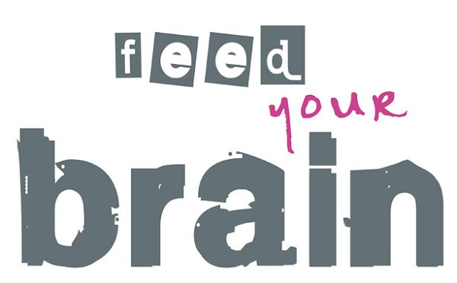

Way to go **Pinellas Central Elementary**! A first-year AVID school with evidence of a college going culture that is schoolwide.

The table groups in the classrooms are labeled with college names. There are signs with every staff member’s collegiate or military pasts on their doors. Teachers all have college material up in their classrooms.

What are other great ideas of a college going culture? Remember “college going” can mean high school and middle school, or highlighting careers and the military!!!

Avidelementaryweekly.org

AVID.org – myavid

Community tab – Filesharing – Elementary

In the elementary section there are links to family workshops and implementation resources.

AVID.org – myavid

Certification Tab and Data Entry Tab

Review your data from last year and see areas of strength and growth

<http://www.pinterest.com/avid4college/>

<https://www.youtube.com/user/AVIDaboutAVID>

https://www.facebook.com/AVIDCenter?ref=br_tf

Shout Outs:

Be inspired and inspire others!

<https://www.youtube.com/watch?v=l-gQLqv9f4o&list=SPzvRx_johoA-YabI6FWcU-jL6nKA1Um-t>

Resources:

**Next Steps**

Complete the site survey

Complete the initial student assessment

Set the schedule for site team meetings

Send your meeting schedule to Kerrale Prince at [princeke@pcsb.org](mailto:princeke@pcsb.org)

Begin ISS data and solidifying site priorities and roles for the site team.