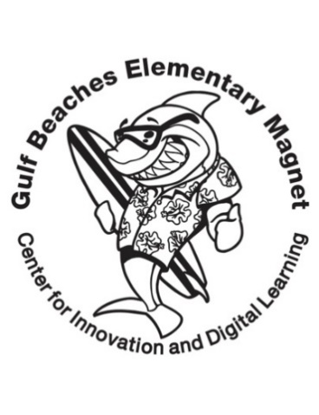2023-2024 Gulf Beaches Elementary Magnet School

**5th Grade Suggested School Supply List**

Your child will use the following items in class this year.

If you are able, please provide the following:

* 5 plastic folders- 2 pocket/3 prong
  + Suggested: 1 blue, 1 yellow, 1 red, 1 green, and 1 free choice
* 5 wide ruled composition notebooks
  + Suggested: 1 blue, 1 yellow, 1 red, 1 green, and 1 free choice
* Ear buds or headphones \***Required**
* Pencils
* Multicolored Post-It notes (3x3)
* Multicolored Expo markers (fine tip preferred)
* Wide Markers
* Wide ruled notebook paper (50 sheets)
* Pencil bag or pencil case *Optional
* HW Planner/Calendar (Optional)

Wishlist:

* **Tissues**
* Disinfectant wipes
* Hand Soap & Sanitizer
* Band-Aids